25 de mayo de 2024
Octavio Vázquez Solorio && JESÚS ALEJANDRO ANTONIO ROCHA
UNIVERSIDAD POLITÉCNICA DE SAN LUIS POTOSÍ

Manual del usuario Y PROGRAMADOR
PROGRAMACIÓN I

MANUAL DEL USUARIO
Contenido
1. INTRODUCCIÓN 1
2. OBJETIVOS 1
3. REQUISITOS DEL SISTEMA 2
4. INSTALACIÓN 3
5. DESCRIPCIÓN DEL JUEGO 4
6. GENERALIDADES 4
7. NAVEGACIÓN DEL MENÚ 5
8. FUNCIONALIDADES 6
9. RESOLUCIÓN DE PROBLEMAS COMUNES 7

1. INTRODUCCIÓN
El juego de memorama es un juego clásico que desafía la memoria de los jugadores al hacerles encontrar pares de cartas idénticas. Este manual del usuario está diseñado para guiarte a través de la instalación y uso del juego de memorama implementado en C++.


2. OBJETIVOS
1° Desarrollar habilidades en la gestión y manipulación de datos mediante el uso de constantes, variables y estructuras de datos avanzadas:
- Comprender el uso de constantes y variables en la programación.
- Trabajar con arreglos unidimensionales y bidimensionales de diferentes tipos de datos.
- Implementar y utilizar uniones y estructuras, incluyendo arreglos de estructuras.
2° Aplicar conceptos de control de flujo y ciclos para la resolución de problemas complejos:
- Utilizar condicionales como if y switch para la toma de decisiones en el código.
- Implementar ciclos for, while y do-while para la repetición controlada de bloques de código.
3° Dominar el uso de funciones y el paso de parámetros para modularizar y optimizar el código:
- Definir y utilizar funciones para dividir problemas en subproblemas más manejables.
- Implementar el paso de parámetros por valor y por referencia para maximizar la eficiencia y flexibilidad del código.
4° Manipular archivos y realizar operaciones avanzadas de entrada y salida de datos:
- Trabajar con archivos para leer y escribir datos, manejando diferentes formatos y estructuras.
- Utilizar el código ASCII para la manipulación de caracteres y datos textuales.

3. REQUISITOS DEL SISTEMA
Antes de comenzar, asegúrate de que tu sistema cumpla con los siguientes requisitos:
- Sistema Operativo: Windows, macOS o Linux
- Compilador de C++ compatible con el estándar C++11 o superior (por ejemplo, GCC, Clang, MSVC)
- Editor de texto o entorno de desarrollo integrado (IDE) para C++ (opcional pero recomendado: Visual Studio Code, CLion, Code::Blocks, etc.)
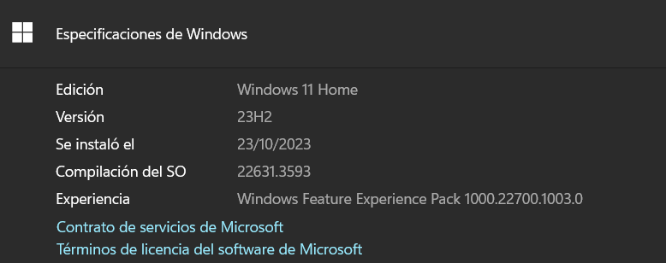

4. INSTALACIÓN
- Descarga del Código Fuente: Alternativamente, puedes descargar el archivo ZIP del proyecto y descomprimirlo en tu máquina.
- Configuración del Entorno: Asegúrate de tener un compilador de C++ instalado en tu sistema.
- Compilación: Al descargar el ZIP del proyecto y descomprimirlo, dentro de la carpeta encontrará varios archivos, pero solo abrirá el archivo cuyo nombre es Juego_1.dev, ya con el archivo abierto teclea F11 y podrá comenzar a jugar.
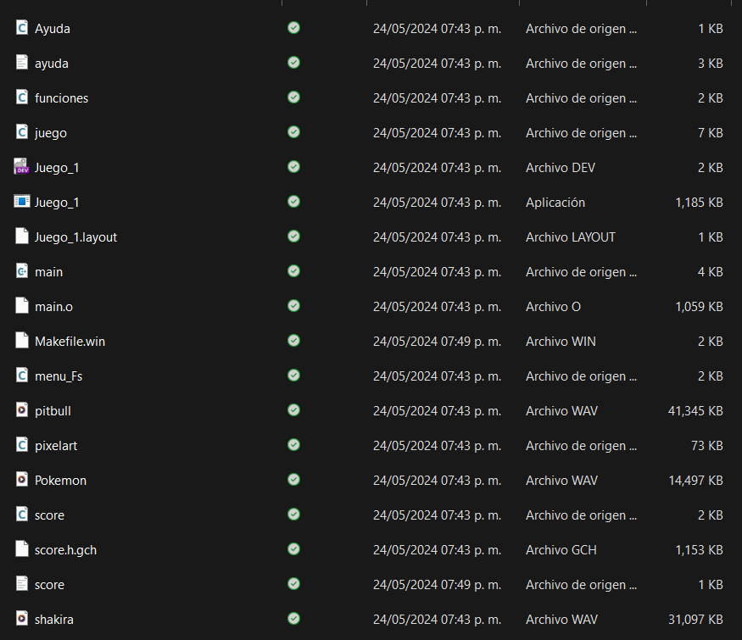

5. DESCRIPCIÓN DEL JUEGO
El memorama es un juego en el que las cartas se colocan boca abajo sobre una superficie plana y el objetivo es encontrar todas las parejas de cartas iguales. En cada turno, el jugador voltea dos cartas. Si son iguales, el jugador gana puntos y las cartas permanecen volteadas. Si no son iguales, las cartas se voltean de nuevo y el jugador vuelve a voltear las cartas hasta encontrar todos los pares.

6. GENERALIDADES
El juego de memorama en C++ incluye las siguientes generalidades:
- Interfaz de Usuario basada en consola: La interacción se realiza mediante la consola, donde se muestra el tablero y se reciben las entradas del jugador.
- Configuración de tamaño de tablero: El juego tendrá un tablero de tamaño de 10x10, sin posibilidad de cambiarlo.
- Modo de juego: El juego solo puede ser para un solo jugador.
- Sistema de puntuación: El juego lleva un registro de las parejas encontradas por cada jugador y muestra el puntaje final al terminar el juego.
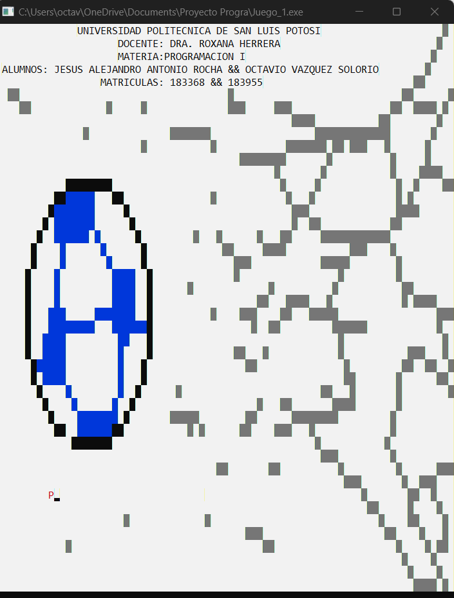

7. NAVEGACIÓN DEL MENÚ
Al iniciar el juego, el usuario verá un menú principal con las siguientes opciones:
- Game: Comienza una nueva partida de memorama.
- Ayuda: Se especifican las reglas del juego, así como su funcionamiento y ayuda a ciertos errores comunes y como pueden arreglarse.
- Score: Permite al usuario observar la tabla de puntajes del juego.
- Salir: Cierra el juego.
- Para seleccionar una opción, el usuario debe presionar "Enter" en cada una de las opciones que quiera elegir.
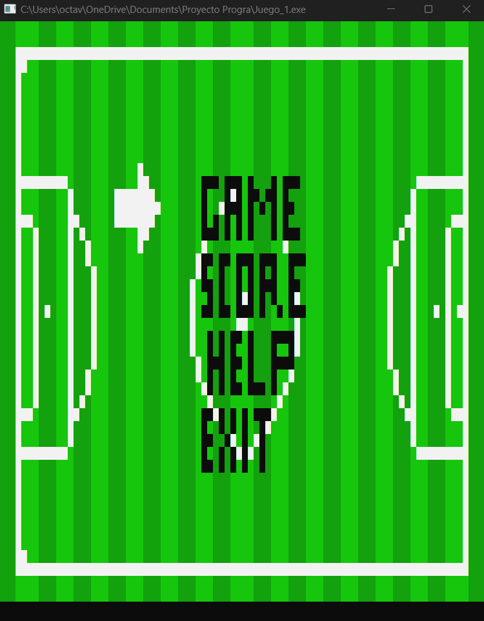

8. FUNCIONALIDADES
Durante el juego, el jugador interactúa con el tablero a través de la consola. Los pasos para jugar son los siguientes:
- Mover Cartas: El jugador contara con las flechas de su teclado para moverse libremente por todo el tablero sin importar el orden en el que se quiera mover.
- Seleccionar Cartas: El jugador debe de posicionarse en una de las dos cartas que desea voltear. Al posicionarse se presionará la tecla “ENTER” y se volteará la carta, el mismo proceso se repetirá para la segunda carta.
- Verificación de Parejas: Si las dos cartas seleccionadas son iguales, permanecen volteadas y el jugador gana puntos. Si no son iguales, las cartas se voltean nuevamente.
- Final del Juego: El juego termina cuando todas las parejas han sido encontradas. El sistema muestra el puntaje final de cada jugador.
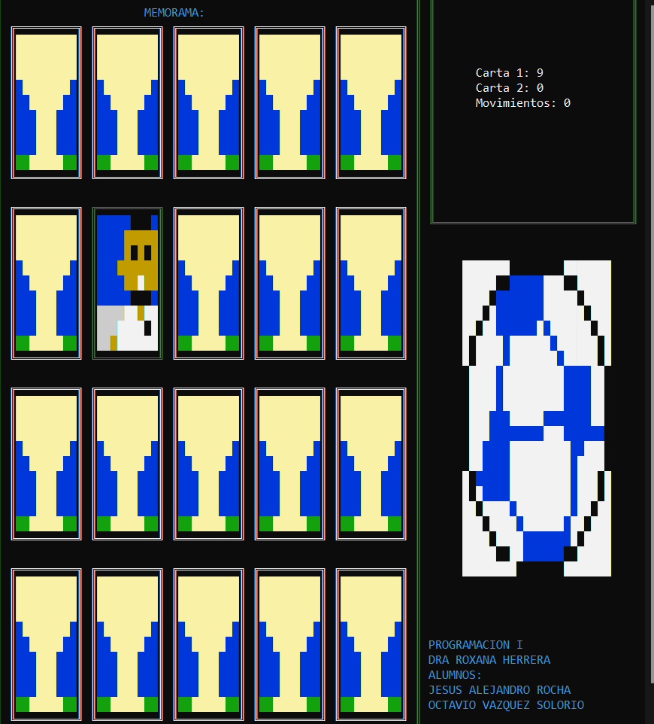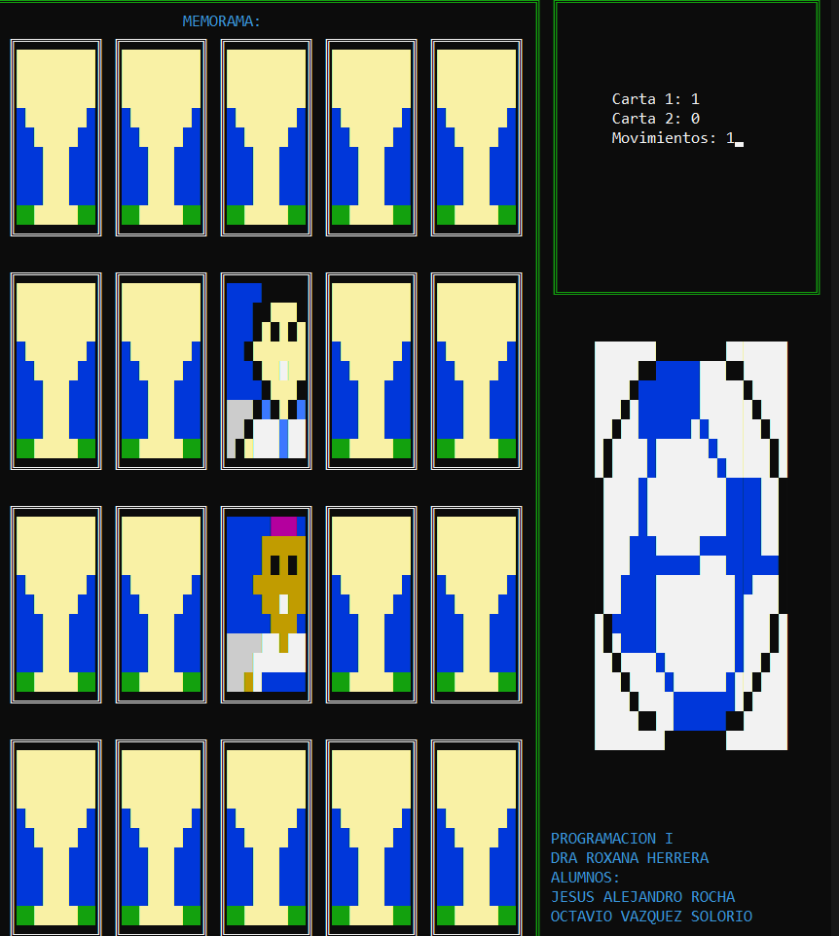
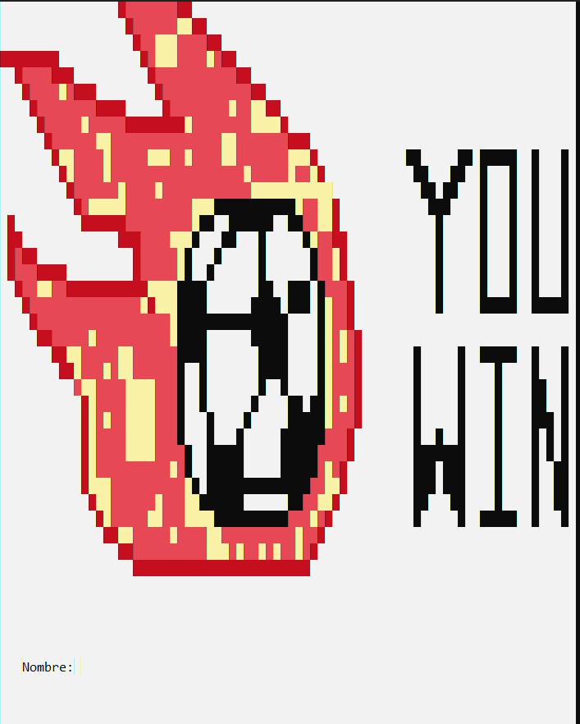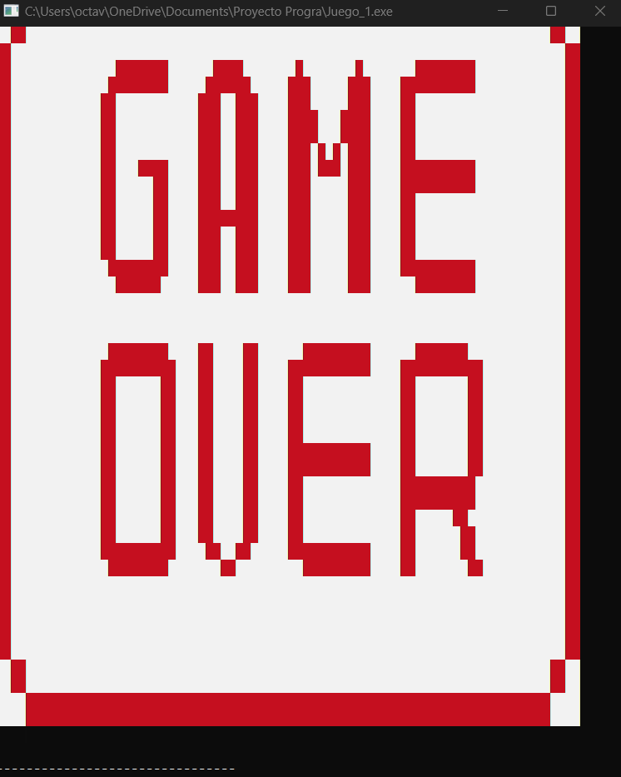

9. RESOLUCIÓN DE PROBLEMAS COMUNES
El juego no compila:
- Asegúrate de que tienes instalado un compilador de C++.
- Verifica que estás la terminal correcta al ejecutar el comando de compilación.
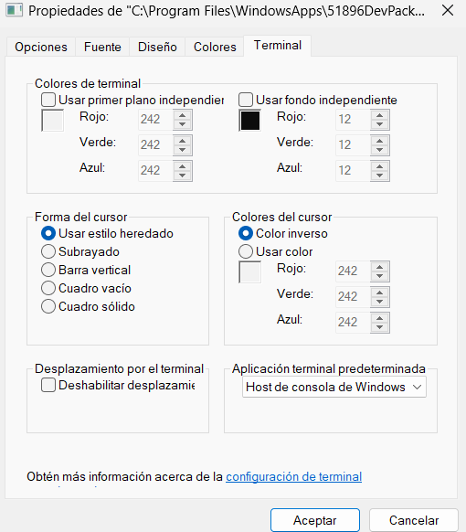

MANUAL DEL PROGRAMADOR
Contenido
Análisis y diseño del proyecto. 9
Funciones Principales: 9
Archivos: 9
Diagrama general de Flujo de Datos 10
Descripción de constantes usadas en el proyecto. 10
Descripción de funciones usadas y paso de parámetros. 11
Librería: menú_Fs.h 11
Librería: juego.h 12
Librería: funciones.h 17
Librería: pixelart.h 18
Librería: score.h 19
Descripción de arreglos utilizados en el proyecto. 22
Descripción de estructuras y arreglos de estructuras. 48
Descripción de archivos en el proyecto. 48
Problemas resueltos en la creación del proyecto. 50

Análisis y diseño del proyecto.
Para este proyecto empleamos un repertorio de funciones que se encuentran a continuación y simplemente se van llamando de forma “secuencial” en la parte del main. Para conformar el programa funcional.
A su vez en este programa nos encontramos con la posibilidad de 4 opciones las cuales son el juego, la ayuda (mostrada vía archivos), el score (manipulado igual vía archivos), y la opción salir que marca el fin del programa, también en cada una de ella se logra encontrar música. Estas funcionalidades del proyecto están dadas por las siguientes funciones:

Funciones Principales:
- Muestramenu
- Scroll_menu
- Mainjuego
- ayuda
- Readplayers
- ordenaplayers
- printfpalyers
- mainpixelart
Estructuras Principales:
- player
- abiertas

Archivos:
- Score.txt
- Ayuda.txt
- Shakira.wav
- Pitbull.wap
- Pokemon.wap

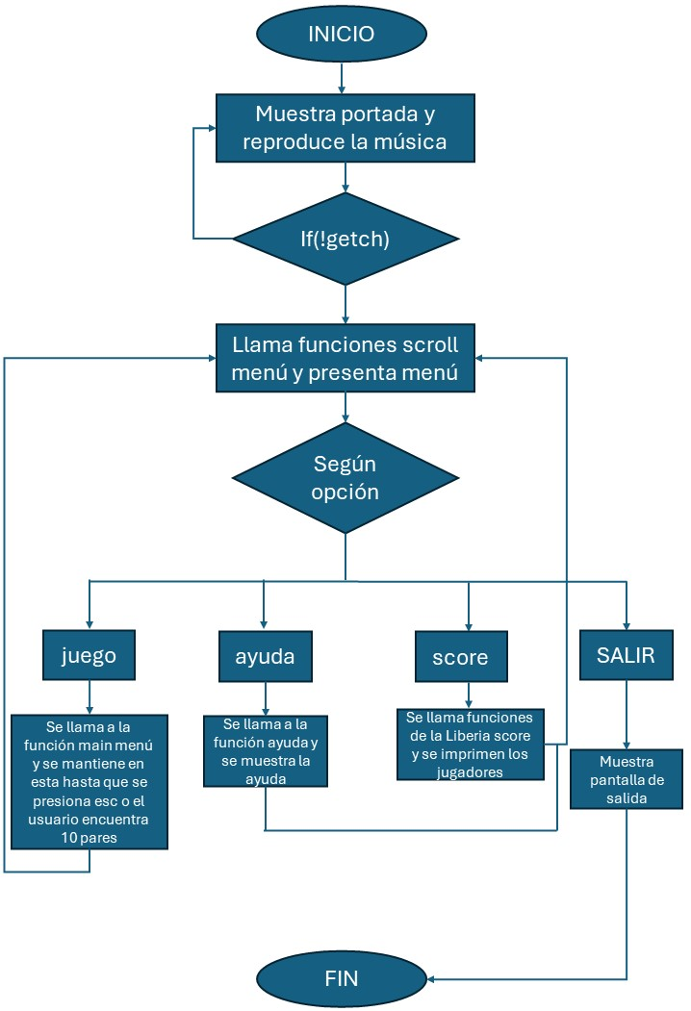
Diagrama general de Flujo de Datos

Descripción de constantes usadas en el proyecto.
A lo largo de este proyecto estaremos usando el siguiente bloque de variables para definir la movilidad dentro de nuestro de nuestro juego con las variables de up, down, left and right. Por otro lado, las variables de enter y esc la primera será para interactuar con las opciones y la segunda para salir del juego y/o programa en cualquier momento. Finalmente, el SPACE define el espacio de separación que tendrán los cuadros en el tablero
// Constantes que emplearemos para la dirección de la tecla y confirmación de opciones
#define RIGHT 77//Flecha a la derecha
#define LEFT 75//Flecha a la izquierda
#define DOWN 80 //Flecha hacia abajo
#define UP 72 //Flecha hacia arriba
#define ENTER 13 //Tecla de Enter.
#define ESC 27 //Tecla ESC para salir de inmediato
#define SPACE 2 //ESPACIO ENTRE CUADROS

Descripción de funciones usadas y paso de parámetros.
Para las funciones creamos nuestras propias librerías que contienen dichas funciones, aquí las desglosare:

Librería: menú_Fs.h
Nuestra primer función es presenta menú, es una función de tipo void por lo cual no regresa nada, le pasamos por parámetro 2 valores los cuales serán su posición en x y en y, y de lo único que se encarga es de limpiar la pantalla de portada, ajustar la dimensión de la terminal, reproducir la música del menú y por ultimo imprimir un pixel art que ya contiene las opciones que mostraremos.
void presenta_menu(int posX, int posY)
{
system("cls");
system("MODE 84,47");
sndPlaySound("pokemon.wav", SND_ASYNC | SND_FILENAME | SND_NOSTOP && SND_LOOP);
campo(Kane,45,92,0,0);
}
Nuestra segunda función es la de scroll_menu, esta función es de tipo int dado que nos regresara el valor de la opción seleccionada, esta función es la que nos permite deslizar el pixel art de la flecha para acomodarla en la opción seleccionada, borrando su rastro a través de otro pixel art , a la par que se pulsa ya sea la tecla arriba o abajo la opción va aumentando o disminuyendo, a esta función le pasamos 3 valores por parámetro los cuales son la posición en x, y así como el numero de opciones que queremos.
int scroll_menu(int posX, int posY, int cantOpc)
{
char tecla='\0';
int op=1,y=posY;
posX=posX+10;
flecha(arrow,9,9,posX,posY);
do{
tecla=getch();
SetConsoleTextAttribute(GetStdHandle (STD_OUTPUT_HANDLE),0);
flecha(arrow2,9,9,posX,y);
if(tecla==80 && op<cantOpc)// 'P' 80 ABAJO
{ y=y+6;
op++;
}
if(tecla==72 && op>1)//'H' ARRIBA
{ y=y-6;
op--;
}
flecha(arrow,9,9,posX,y);
}while(tecla!=27 && tecla!=13);//ESC 27 ENTER 13
return (op);
}

Librería: juego.h
Esta librería posee todo lo referente al juego de memorama. Nuestra primer función será el main juego, la cual es la función principal de la librería. En esta función es de tipo void y sin parámetros, inicia reproduciendo la música luego define variables de ren,cols el ancho y alto de los cuadros y el arreglo bidimensional de infoTabla, luego manda llamar 2 veces a la funcion cuadro para dibujar cuadros, luego a la funcion asigna cartas para asignar el valor a cada carta, luego de ello imprime el tablero con la funcion tablero, escribe un bloque de texto, espera 1800 micro segundos y oculta las cartas para finalmente permitirnos desplazar por el tablero con la funcion moverCuadro.
void mainJuego()
{
sndPlaySound("shakira.wav", SND_ASYNC | SND_FILENAME | SND_LOOP);
int ren=4, col=5, ancho=10, alto=10;
int infoTabla[4][5]={0};
cuadro(0.5,0.5,62,49,2);
cuadro(64,0.5,30,15,2);
asignaCartas(infoTabla);
tablero(2,2,ancho,alto,ren,col,infoTabla);
SetConsoleTextAttribute(GetStdHandle (STD_OUTPUT_HANDLE),3);
gotoxy(22,1);
printf("MEMORAMA:");
gotoxy(64,43);
printf("PROGRAMACION I");
gotoxy(64,44);
printf("DRA ROXANA HERRERA");
gotoxy(64,45);
printf("ALUMNOS:");
gotoxy(64,46);
printf("JESUS ALEJANDRO ROCHA");
gotoxy(64,47);
printf("OCTAVIO VAZQUEZ SOLORIO\n");
bb(balon,21,22,69,18);
Sleep(1800);
ocultacartas(2,2,ancho,alto,ren,col,infoTabla);
moverCuadro(2,2,ancho,alto,ren,col,infoTabla);
}
La segunda función es la de cuadro, esta funcion es de tipo void, y nos permite dibujar un marco, a dicha función le pasaremos 5 valores por parámetro, la posición inicial de x y de y, lo ancho y alto que queremos que sea el cuadro y el color de este.
void cuadro(int posX,int posY,int ancho,int alto,int color)
{
int i;
SetConsoleTextAttribute(GetStdHandle (STD_OUTPUT_HANDLE),color);
for(i=0;i<ancho;i++)//horizontales
{
gotoxy(posX+i,posY);
printf("%c",205);//--- 196
gotoxy(posX+i,posY+alto);
printf("%c",205);//=
// Sleep(100);
}
for(i=0;i<alto;i++)
{
gotoxy(posX,posY+i);
printf("%c",186);//||
gotoxy(posX+ancho,posY+i);
printf("%c",186);//||
}

gotoxy(posX,posY);printf("%c",201);
gotoxy(posX+ancho,posY);printf("%c",187);
gotoxy(posX,posY+alto);printf("%c",200);
gotoxy(posX+ancho,posY+alto);printf("%c",188); //217

}
La tercer función es la de Tablero, esta función es la que nos permite imprimir el tablero y las tarjetas del memorama. Esta función es de tipo Void, a su vez recibe 6 valores por parámetro y un arreglo por referencia, a su vez primero imprime el pixel art según el valor que se encuentre en la posición de i y j en el arreglo infotabla. Después de imprimir el pixel art imprime sum arco.
void tablero(int posX,int posY,int ancho, int alto,int rens, int cols,int infoTabla[4][5])
{
int x, y, i,j, color=15;
for(y=posY,i=0;i<rens;i++,y=y+alto+SPACE)//renglones
for(x=posX,j=0;j<cols;j++,x=x+ancho+SPACE)//columnas
{
selecPixel(infoTabla[i][j],10,10,x,y);
cuadro(x,y,ancho,alto,15);
}
}
La cuarta función es ocultarcartas, esta función de igual manera es de tipo void, vez recibe 6 valores por parámetro y un arreglo por referencia, esta función nos permite imprimir el pixel art que esconde los demás pixel arts.
void ocultacartas(int posX,int posY,int ancho, int alto,int rens, int cols,int infoTabla[4][5])
{
int x, y, i,j, color=15;
for(y=posY,i=0;i<rens;i++,y=y+alto+SPACE)//renglones
for(x=posX,j=0;j<cols;j++,x=x+ancho+SPACE)//columnas
{

selecPixel(10,10,10,x,y);
cuadro(x,y,ancho,alto,15);
}
}
La quinta función es asignaCartas, esta función es de tipo void, y se le pasa el arreglo infoTabla por referencia, esta función únicamente asigna números del 0 al 9 como máximo 2 veces, esto para tener pares. Y esto se van asignando a cada posición del arreglo infoTabla.
void asignaCartas(int infoTabla[4][5])
{
int check[10]={0};//Ningun valor asignado
int i=0, num=0, j=0;

for(i=0;i<4;i++)
{
for(j=0;j<5;j++)
{
do{
num=rand()%10;
}while(check[num]==2);
check[num]++;//Asignar 2 veces el numero de una carta
infoTabla[i][j]=num;//Se asigna a la tabla
}
}
}
Por ultimo la sexta función de esta librería es la de mover cuadro esta función de igual manera es de tipo void y recibe 6 valores por parámetro y un arreglo por referencia, inicia declarando algunas variables y arreglos que emplearemos, a grandes rasgos permite la movilidad a través del tablero permitiendo la selección y navegación por las tarjetas del tablero, a la par en el caso enter tenemos la validación para comparar si los pares son pares o no, además de nuestro contador de movimientos y la cantidad de pares. Toda esta función esta sujeta a la validación de que no se presiona la tecla esc o que no se encuentren los 10 pares, al encontrarse se cambia la pantalla a la de ganaste y pide el nombre del usuario, a la par que frena la música.
void moverCuadro(int posX, int posY, int ancho, int alto, int ren, int col, int infoTabla[4][5])
{
int x=posX, y=posY;
int i=0, j=0;
char tecla=0;
/////////////--Para Score--///////////////
char userName[20];
int puntos;
char nomArch[20]="score.txt";
player users[6]; //arreglo de estructuras para los jugadores
/////////////////
int checkTabla[4][5]={0};//
int contOpen=0;//Contador de cartas abiertas
abierta c[2]={{0,0,0},{0,0,0}};//Pares de cartas que se abren

cuadro(x,y,ancho,alto,2);//Pinta cuadro inicial
do{
tecla=getch();
cuadro(x,y,ancho,alto,15);
switch(tecla){
case RIGHT:
if(j<(col-1)){
j++;
x=x+ancho+SPACE;
}
break;
case DOWN:
if(i<(ren-1)){
i++;
y=y+alto+SPACE;
}
break;
case LEFT:
if(j>0){
j--;
x=x-ancho-SPACE;
}
break;
case UP:
if(i>0){
i--;
y=y-alto-SPACE;
}
break;
case ENTER:
if(contOpen<2)//Se destapan las cartas
{
if (checkTabla[i][j]==0)
{
cuadro(x,y,ancho,alto,14);
Sleep(200);
gotoxy(x+(ancho/2),y+(alto/2)+1);
SetConsoleTextAttribute(GetStdHandle(STD_OUTPUT_HANDLE),15);
printf("%d",infoTabla[i][j]);
checkTabla[i][j]=1;
//Guardar carta
c[contOpen].i=i;
c[contOpen].j=j;
c[contOpen].x=x;
c[contOpen].y=y;
c[contOpen].infoCarta=infoTabla[i][j];
//////////////////////////////
gotoxy(71,5);
printf("Carta 1: %d",c[contOpen].infoCarta);
selecPixel(c[contOpen].infoCarta,10,10,c[contOpen].x,c[contOpen].y);
cuadro(c[contOpen].x,c[contOpen].y,10,10,15);
contOpen++;
gotoxy(71,6);
printf("Carta 2: %d",c[contOpen].infoCarta);
gotoxy(71,7);
printf("Movimientos: %d",movs);
}
if(contOpen==2)
{
if(c[0].infoCarta==c[1].infoCarta)
{
//checkabiertas[c[0].infoCarta]=1;
gotoxy(71,8);
contOpen=0;
pares++;
printf("Pares encontrados: %d",pares);
}
else//Desmarcar la carta
{
Sleep(300);
//desmarcar las cartas
checkTabla[c[0].i][c[0].j]=0;
checkTabla[c[1].i][c[1].j]=0;
//Borra el numero carta 1
selecPixel(10,10,10,c[0].x,c[0].y);
cuadro(c[0].x,c[0].y,10,10,15);
//Borra el numero carta 2
selecPixel(10,10,10,c[1].x,c[1].y);
cuadro(c[1].x,c[1].y,10,10,15);
contOpen=0;
}
movs++;
}
}
break;
}
cuadro(x,y,ancho,alto,2);
}while(tecla!=27 && pares<10);
if(pares==10){
pares=0;
system("MODE 80,46");
screen(win,45,88,0,0);
SetConsoleTextAttribute(GetStdHandle (STD_OUTPUT_HANDLE),240);
gotoxy(3,40);
printf("Nombre:");
scanf("%s",userName);
sndPlaySound(NULL, SND_ASYNC | SND_FILENAME | SND_ASYNC);
readPlayers(nomArch,users);
ordenaPlayers(userName,movs,users);
savePlayers(nomArch,users);
movs=0;
}

}

Librería: funciones.h
En esta librería encontramos 2 funciones, el gotoxy que nos permite mover a cualquier parte de la consola, esto recibiendo 2 parámetros, la posición en x y en y. Mientras que la función texto que nos permite tener un texto dinámico en la portada. A la par recibe 2 parámetros en x y en y, para poder acomodarlo.
void gotoxy(int x,int y){
HANDLE hcon;
hcon = GetStdHandle(STD_OUTPUT_HANDLE);
COORD dwPos;
dwPos.X = x;
dwPos.Y= y;
SetConsoleCursorPosition(hcon,dwPos);
}

void texto(int x, int y){
do{
gotoxy(x,y);
SetConsoleTextAttribute(GetStdHandle(STD_OUTPUT_HANDLE),244);
Sleep(300);printf("P");Sleep(300);printf("R");Sleep(300);printf("E");Sleep(300);printf("S");Sleep(300);printf("I");Sleep(300);printf("O");Sleep(300);printf("N");Sleep(300);printf("A");
printf(" ");Sleep(300);
printf("E");Sleep(300);printf("N");Sleep(300);printf("T");Sleep(300);printf("E");Sleep(300);printf("R");Sleep(300);printf(" ");Sleep(300);printf("P");Sleep(300);printf("A");Sleep(300);printf("R");
printf("A");Sleep(300);
printf(" ");Sleep(300);printf("J");Sleep(300);printf("U");Sleep(300);printf("G");Sleep(300);printf("A");Sleep(300);printf("R");Sleep(300);
gotoxy(x,y);
for(int j=0;j<26;j++){
SetConsoleTextAttribute(GetStdHandle(STD_OUTPUT_HANDLE),15);
printf("%c",219);
}
SetConsoleTextAttribute(GetStdHandle(STD_OUTPUT_HANDLE),244);
}while(!_kbhit());
}

Librería: pixelart.h
Aquí encontraremos varias funciones sin embargo solo hay 2 principales y de la función main píxel art es de la cual derivan las demás pues solo adaptan el tamaño del array que reciben.
En la funcion selecPixel, recibe el numero de caso o de pixel que va a imprimir, el tamaño en renglones y columnas, así como la posición en x y en y todos estos valores por parámetro.
void selecPixel(int num,int ren, int col, int posX, int posY){
switch(num){
case 0:mainPixelArt(pixel0,ren,col,posX,posY);break;
case 1:mainPixelArt(pixel1,ren,col,posX,posY);break;
case 2:mainPixelArt(pixel2,ren,col,posX,posY);break;
case 3:mainPixelArt(pixel3,ren,col,posX,posY);break;
case 4:mainPixelArt(pixel4,ren,col,posX,posY);break;
case 5:mainPixelArt(pixel11,ren,col,posX,posY);break;
case 6:mainPixelArt(pixel6,ren,col,posX,posY);break;
case 7:mainPixelArt(pixel7,ren,col,posX,posY);break;
case 8:mainPixelArt(pixel8,ren,col,posX,posY);break;
case 9:mainPixelArt(pixel9,ren,col,posX,posY);break;
case 10:copa(copa2,10,10,posX,posY);break;
}
}

En la función mainpixel de la cual derivan las demás recibe de igual manera el valor de columna, renglón, y la posición en x y en y así como el arreglo del pixel art a imprimir.
int mainPixelArt(int arreglo[16][16],int ren, int col, int posX, int posY)
{
int i=0,j=0;
int x=posX, y=posY;

for(i=0,y=posY;i<ren;i++,y++){
for(j=0,x=posX;j<col;j++,x++){
SetConsoleTextAttribute(GetStdHandle(STD_OUTPUT_HANDLE),arreglo[i][j]);
gotoxy(x,y);
printf("%c",219);
}
printf("\n");
}
SetConsoleTextAttribute(GetStdHandle(STD_OUTPUT_HANDLE),15);
return 0;
}
Funciones adaptadas:
int mainPortada(int arreglo[45][79],int ren, int col, int posX, int posY);
int flecha(int arreglo[9][9],int ren, int col, int posX, int posY);
int pmenu(int arreglo[29][65],int ren, int col, int posX, int posY);
int copa(int arreglo[12][12],int ren, int col, int posX, int posY);
int campo(int arreglo[45][92],int ren, int col, int posX, int posY);
int screen(int arreglo[45][88],int ren, int col, int posX, int posY);
int bb(int arreglo[21][22],int ren, int col, int posX, int posY);

Librería: score.h
Primera función: Readplayers pasamos 2 arreglos uno de estructuras llamado users y uno que contiene el nombre de nuestro archivo, con esto abrimos el archivo de tipo lectura y con un ciclo hasta el final del archivo vamos asignado a los campos del arreglo user en las posiciones de i.
void readPlayers(char nomArch[20],player users[6])
{
FILE *arch=NULL;
int i=0;
arch=fopen(nomArch,"r");
if(arch)
{
i=0;
while(!feof(arch))
{
fscanf(arch,"%[^\t]",users[i].userName);
fscanf(arch,"%d\n",&users[i].puntos);
i++;
}
fclose(arch);
}
}
Segunda función printPlayers, solamente recibe por referencia el arreglo users e imprime los que tiene dentro.
void printPlayers(player users[6])
{
int i;
for(i=0;i<5;i++)
printf("%s\t%d\n", users[i].userName,users[i].puntos);
}

Tercer Función ordenaPlayers, con esta funcion, igual manera le pasamos los parámetros de el nombre del archivo y nuestro arreglo de users por referencia y la variable int por parámetro (que a posterior serán los movimientos). Y esta funcion a través del método de burbuja ordena los elementos del arreglo de users de menor a mayor puntaje.
void ordenaPlayers(char userName[20], int puntos, player users[6])//burbuja
{
int i, j,n=6;
player aux;

strcpy(users[5].userName,userName);
users[5].puntos=puntos;

for(i=0;i<n-1;i++){
for(j=0; j < n-1; j++) {
if(users[j].puntos > users[j+1].puntos)
{
aux = users[j];
users[j] = users[j+1];
users[j+1] = aux;
}//swap
}//for j
}//for i
}
Cuarta función savePlayers, pasamos el el archivo del nombre del archivo y de el arreglo de estructura por referencia y con esto creamos o reemplazamos nuestro archivo con el nombre de los jugadores.
void savePlayers(char nomArch[20],player users[6])
{
FILE *arch=NULL;
int i=0;
arch=fopen(nomArch,"w");//reemplaza el archivo o lo crea
if(arch)
{
for(i=0;i<5;i++)
{
fprintf(arch,"%s\t",users[i].userName);
fprintf(arch,"%d\n",users[i].puntos);
}
fclose(arch);
}
}

Descripción de arreglos utilizados en el proyecto.
Los arreglos que tenemos son principalmente los pixel arts, sin embargo los que no son pixel arts son los siguientes:
char nomArch[20]="score.txt"; //Asignamos el nombre del arcivo de el score para las puntuaciones
int infoTabla[4][5]={0}; //Es donde se van a asignar los numeros de cada carta
int checkTabla[4][5]={0};// Nos permite checar que cartas se han destapado

Los pixelarts son los siguientes:
//-------------------- Flecha del menu------------------------------------
int arrow[9][9]={
{ 2, 2, 10, 10, 10, 2, 2, 2, 10 },
{ 2, 2, 10, 10, 15, 2, 2, 2, 10 },
{ 2, 2, 10, 10, 15, 15, 2, 2, 10 },
{ 15, 15, 15, 15, 15, 15, 15, 2, 10 },
{ 15, 15, 15, 15, 15, 15, 15, 15, 10 },
{ 15, 15, 15, 15, 15, 15, 15, 2, 10 },
{ 2, 2, 10, 10, 15, 15, 2, 2, 10 },
{ 2, 2, 10, 10, 15, 2, 2, 2, 10 },
{ 2, 2, 10, 10, 10, 2, 2, 2, 10 },
};
int arrow2[9][9]={
{ 2, 2, 10, 10, 10, 2, 2, 2, 10 },
{ 2, 2, 10, 10, 10, 2, 2, 2, 10 },
{ 2, 2, 10, 10, 10, 2, 2, 2, 10 },
{ 2, 2, 10, 10, 10, 2, 2, 2, 10 },
{ 2, 2, 10, 10, 10, 2, 2, 2, 10 },
{ 2, 2, 10, 10, 10, 2, 2, 2, 10 },
{ 2, 2, 10, 10, 10, 2, 2, 2, 10 },
{ 2, 2, 10, 10, 10, 2, 2, 2, 10 },
{ 2, 2, 10, 10, 10, 2, 2, 2, 10 },
};

///////////////////////--------------------Pixelarts de cartas------------------------------------------////////////////////////////////////////////////////////////////
int pixel0[16][16]={
{ 1, 1, 1, 1, 1, 1, 1, 1, 1, 1, 1, 1, 1, 1, 1, 1 },
{ 1, 1, 1, 1, 1, 6, 6, 6, 6, 6, 1, 1, 1, 1, 1, 1 },
{ 1, 1, 1, 1, 6, 14, 14, 14, 14, 14, 6, 1, 1, 1, 1, 1 },
{ 1, 1, 1, 1, 6, 14, 0, 14, 0, 14, 6, 1, 1, 1, 1, 1 },
{ 1, 1, 1, 1, 14, 14, 14, 14, 14, 14, 14, 1, 1, 1, 1, 1 },
{ 1, 1, 1, 1, 1, 14, 14, 15, 14, 14, 1, 1, 1, 1, 1, 1 },
{ 1, 1, 1, 1, 1, 1, 6, 6, 6, 1, 1, 1, 1, 1, 1, 1 },
{ 7, 7, 7, 7, 7, 4, 4, 14, 4, 4, 7, 7, 7, 7, 7, 7 },
{ 7, 7, 7, 7, 4, 1, 4, 1, 4, 1, 4, 7, 7, 7, 7, 7 },
{ 7, 7, 7, 14, 4, 1, 4, 1, 4, 1, 4, 14, 7, 7, 7, 7 },
{ 7, 7, 7, 14, 7, 1, 4, 1, 4, 1, 7, 14, 7, 7, 7, 7 },
{ 7, 7, 7, 7, 7, 7, 8, 8, 8, 7, 7, 7, 7, 7, 7, 7 },
{ 7, 7, 7, 7, 7, 7, 8, 0, 8, 7, 7, 7, 7, 7, 7, 7 },
{ 10, 10, 10, 10, 10, 10, 15, 0, 15, 10, 10, 10, 10, 10, 10, 10 },
{ 10, 10, 10, 10, 10, 10, 10, 10, 10, 10, 10, 10, 10, 10, 10, 10 },
{ 10, 10, 10, 10, 10, 10, 10, 10, 10, 10, 10, 10, 10, 10, 10, 10 },
};
int pixel1[16][16]={
{ 1, 1, 1, 1, 1, 1, 1, 1, 1, 1, 1, 1, 1, 1, 1, 1 },
{ 1, 1, 1, 1, 1, 1, 13, 13, 13, 1, 1, 1, 1, 1, 1, 1 },
{ 1, 1, 1, 1, 1, 6, 6, 6, 6, 6, 1, 1, 1, 1, 1, 1 },
{ 1, 1, 1, 1, 1, 6, 0, 6, 0, 6, 1, 1, 1, 1, 1, 1 },
{ 1, 1, 1, 1, 6, 6, 6, 6, 6, 6, 6, 1, 1, 1, 1, 1 },
{ 1, 1, 1, 1, 1, 6, 6, 15, 6, 6, 1, 1, 1, 1, 1, 1 },
{ 1, 1, 1, 1, 1, 1, 6, 6, 6, 1, 1, 1, 1, 1, 1, 1 },
{ 7, 7, 7, 7, 7, 15, 15, 6, 15, 15, 7, 7, 7, 7, 7, 7 },
{ 7, 7, 7, 7, 15, 15, 15, 15, 15, 15, 15, 7, 7, 7, 7, 7 },
{ 7, 7, 7, 6, 15, 1, 1, 1, 1, 1, 15, 6, 7, 7, 7, 7 },
{ 7, 7, 7, 6, 7, 15, 15, 15, 15, 15, 7, 6, 7, 7, 7, 7 },
{ 7, 7, 7, 7, 7, 7, 8, 8, 8, 7, 7, 7, 7, 7, 7, 7 },
{ 7, 7, 7, 7, 7, 7, 8, 0, 8, 7, 7, 7, 7, 7, 7, 7 },
{ 10, 10, 10, 10, 10, 10, 15, 0, 15, 10, 10, 10, 10, 10, 10, 10 },
{ 10, 10, 10, 10, 10, 10, 10, 10, 10, 10, 10, 10, 10, 10, 10, 10 },
{ 10, 10, 10, 10, 10, 10, 10, 10, 10, 10, 10, 10, 10, 10, 10, 10 },
};
int pixel2[16][16]={
{ 1, 1, 1, 1, 1, 1, 1, 1, 1, 1, 1, 1, 1, 1, 1, 1 },
{ 1, 1, 1, 1, 1, 1, 6, 6, 6, 1, 1, 1, 1, 1, 1, 1 },
{ 1, 1, 1, 1, 1, 14, 14, 14, 14, 14, 1, 1, 1, 1, 1, 1 },
{ 1, 1, 1, 1, 1, 14, 0, 14, 0, 14, 1, 1, 1, 1, 1, 1 },
{ 1, 1, 1, 1, 14, 14, 14, 14, 14, 14, 14, 1, 1, 1, 1, 1 },
{ 1, 1, 1, 1, 1, 14, 6, 15, 6, 14, 1, 1, 1, 1, 1, 1 },
{ 1, 1, 1, 1, 1, 1, 6, 6, 6, 1, 1, 1, 1, 1, 1, 1 },
{ 7, 7, 7, 7, 7, 15, 15, 14, 15, 15, 7, 7, 7, 7, 7, 7 },
{ 7, 7, 7, 7, 15, 15, 15, 9, 15, 15, 15, 7, 7, 7, 7, 7 },
{ 7, 7, 7, 14, 15, 15, 15, 9, 15, 15, 15, 14, 7, 7, 7, 7 },
{ 7, 7, 7, 14, 7, 15, 15, 15, 15, 15, 7, 14, 7, 7, 7, 7 },
{ 7, 7, 7, 7, 7, 7, 8, 8, 8, 7, 7, 7, 7, 7, 7, 7 },
{ 7, 7, 7, 7, 7, 7, 8, 0, 8, 7, 7, 7, 7, 7, 7, 7 },
{ 10, 10, 10, 10, 10, 10, 15, 0, 15, 10, 10, 10, 10, 10, 10, 10 },
{ 10, 10, 10, 10, 10, 10, 10, 10, 10, 10, 10, 10, 10, 10, 10, 10 },
{ 10, 10, 10, 10, 10, 10, 10, 10, 10, 10, 10, 10, 10, 10, 10, 10 },
};
int pixel3[16][16]={
{ 1, 1, 1, 1, 1, 1, 0, 0, 0, 1, 1, 1, 1, 1, 1, 1 },
{ 1, 1, 1, 1, 1, 0, 0, 0, 0, 0, 1, 1, 1, 1, 1, 1 },
{ 1, 1, 1, 1, 0, 0, 14, 14, 14, 0, 0, 1, 1, 1, 1, 1 },
{ 1, 1, 1, 1, 0, 0, 0, 14, 0, 0, 0, 1, 1, 1, 1, 1 },
{ 1, 1, 1, 0, 14, 0, 14, 14, 14, 0, 14, 0, 1, 1, 1, 1 },
{ 1, 1, 1, 1, 0, 0, 0, 15, 0, 0, 0, 1, 1, 1, 1, 1 },
{ 1, 1, 1, 1, 1, 0, 0, 0, 0, 0, 1, 1, 1, 1, 1, 1 },
{ 7, 7, 7, 7, 0, 9, 0, 0, 0, 9, 0, 7, 7, 7, 7, 7 },
{ 7, 7, 7, 0, 15, 9, 15, 9, 15, 9, 15, 0, 7, 7, 7, 7 },
{ 7, 7, 0, 14, 15, 9, 15, 9, 6, 9, 15, 14, 0, 7, 7, 7 },
{ 7, 7, 0, 14, 0, 9, 15, 9, 15, 9, 0, 14, 0, 7, 7, 7 },
{ 7, 7, 7, 0, 7, 0, 8, 8, 8, 0, 7, 0, 7, 7, 7, 7 },
{ 7, 7, 7, 7, 7, 0, 8, 0, 8, 0, 7, 7, 7, 7, 7, 7 },
{ 10, 10, 10, 10, 10, 0, 15, 0, 15, 0, 10, 10, 10, 10, 10, 10 },
{ 10, 10, 10, 10, 10, 10, 0, 10, 0, 10, 10, 10, 10, 10, 10, 10 },
{ 10, 10, 10, 10, 10, 10, 10, 10, 10, 10, 10, 10, 10, 10, 10, 10 },
};
int pixel4[16][16]={
{ 9, 9, 9, 9, 9, 9, 0, 0, 0, 9, 9, 9, 9, 9, 9, 9 },
{ 9, 9, 9, 9, 9, 0, 12, 12, 12, 0, 9, 9, 9, 9, 9, 9 },
{ 9, 9, 9, 9, 0, 12, 14, 14, 14, 12, 0, 9, 9, 9, 9, 9 },
{ 9, 9, 9, 9, 0, 14, 0, 14, 0, 14, 0, 9, 9, 9, 9, 9 },
{ 9, 9, 9, 0, 14, 14, 14, 14, 14, 14, 14, 0, 9, 9, 9, 9 },
{ 9, 9, 9, 9, 0, 14, 14, 15, 14, 14, 0, 9, 9, 9, 9, 9 },
{ 9, 9, 9, 9, 9, 0, 14, 14, 14, 0, 9, 9, 9, 9, 9, 9 },
{ 7, 7, 7, 7, 0, 1, 1, 14, 1, 1, 0, 7, 7, 7, 7, 7 },
{ 7, 7, 7, 0, 1, 1, 6, 6, 6, 1, 1, 0, 7, 7, 7, 7 },
{ 7, 7, 0, 1, 1, 1, 1, 1, 6, 1, 1, 1, 0, 7, 7, 7 },
{ 7, 7, 0, 14, 0, 1, 1, 6, 1, 1, 0, 14, 0, 7, 7, 7 },
{ 7, 7, 7, 0, 7, 0, 1, 1, 1, 0, 7, 0, 7, 7, 7, 7 },
{ 7, 7, 7, 7, 7, 0, 15, 15, 15, 0, 7, 7, 7, 7, 7, 7 },
{ 7, 7, 7, 7, 7, 0, 15, 0, 15, 0, 7, 7, 7, 7, 7, 7 },
{ 10, 10, 10, 10, 10, 0, 1, 0, 1, 0, 10, 10, 10, 10, 10, 10 },
{ 10, 10, 10, 10, 10, 10, 0, 10, 0, 10, 10, 10, 10, 10, 10, 10 },
};
int pixel5[16][16]={
{ 1, 1, 1, 1, 1, 0, 0, 1, 1, 1, 1, 1, 1, 1, 1, 1 },
{ 1, 1, 1, 1, 1, 0, 0, 0, 0, 0, 1, 1, 1, 1, 1, 1 },
{ 1, 1, 1, 1, 1, 14, 14, 14, 14, 14, 1, 1, 1, 1, 1, 1 },
{ 1, 1, 1, 1, 1, 14, 0, 14, 0, 14, 1, 1, 1, 1, 1, 1 },
{ 1, 1, 1, 1, 14, 14, 14, 14, 14, 14, 14, 1, 1, 1, 1, 1 },
{ 1, 1, 1, 1, 1, 14, 14, 15, 14, 14, 1, 1, 1, 1, 1, 1 },
{ 1, 1, 1, 1, 1, 1, 14, 14, 14, 1, 1, 1, 1, 1, 1, 1 },
{ 7, 7, 7, 7, 7, 4, 4, 14, 4, 4, 7, 7, 7, 7, 7, 7 },
{ 7, 7, 7, 7, 4, 4, 4, 4, 4, 4, 4, 7, 7, 7, 7, 7 },
{ 7, 7, 7, 4, 4, 4, 4, 4, 4, 4, 4, 4, 7, 7, 7, 7 },
{ 7, 7, 7, 14, 7, 4, 4, 4, 4, 4, 7, 14, 7, 7, 7, 7 },
{ 7, 7, 7, 7, 7, 7, 4, 4, 4, 7, 7, 7, 7, 7, 7, 7 },
{ 7, 7, 7, 7, 7, 7, 10, 7, 10, 7, 7, 7, 7, 7, 7, 7 },
{ 10, 10, 10, 10, 10, 10, 15, 10, 15, 10, 10, 10, 10, 10, 10, 10 },
{ 10, 10, 10, 10, 10, 10, 10, 10, 10, 10, 10, 10, 10, 10, 10, 10 },
{ 10, 10, 10, 10, 10, 10, 10, 10, 10, 10, 10, 10, 10, 10, 10, 10 },
};
int pixel6[16][16]={
{ 1, 1, 1, 1, 1, 1, 0, 0, 0, 1, 1, 1, 1, 1, 1, 1 },
{ 1, 1, 1, 1, 1, 0, 0, 0, 0, 0, 1, 1, 1, 1, 1, 1 },
{ 1, 1, 1, 1, 1, 14, 14, 14, 14, 14, 1, 1, 1, 1, 1, 1 },
{ 1, 1, 1, 1, 1, 14, 0, 14, 0, 14, 1, 1, 1, 1, 1, 1 },
{ 1, 1, 1, 1, 14, 14, 14, 14, 14, 14, 14, 1, 1, 1, 1, 1 },
{ 1, 1, 1, 1, 1, 14, 14, 15, 14, 14, 1, 1, 1, 1, 1, 1 },
{ 1, 1, 1, 1, 1, 1, 14, 14, 14, 1, 1, 1, 1, 1, 1, 1 },
{ 7, 7, 7, 7, 7, 4, 4, 14, 4, 4, 7, 7, 7, 7, 7, 7 },
{ 7, 7, 7, 7, 4, 4, 4, 4, 4, 4, 4, 7, 7, 7, 7, 7 },
{ 7, 7, 7, 4, 4, 4, 4, 4, 4, 4, 4, 4, 7, 7, 7, 7 },
{ 7, 7, 7, 14, 7, 4, 4, 4, 4, 4, 7, 14, 7, 7, 7, 7 },
{ 7, 7, 7, 7, 7, 7, 0, 0, 0, 7, 7, 7, 7, 7, 7, 7 },
{ 7, 7, 7, 7, 7, 7, 0, 7, 0, 7, 7, 7, 7, 7, 7, 7 },
{ 10, 10, 10, 10, 10, 10, 15, 10, 15, 10, 10, 10, 10, 10, 10, 10 },
{ 10, 10, 10, 10, 10, 10, 10, 10, 10, 10, 10, 10, 10, 10, 10, 10 },
{ 10, 10, 10, 10, 10, 10, 10, 10, 10, 10, 10, 10, 10, 10, 10, 10 },
};
int pixel7[16][16]={
{ 1, 1, 1, 1, 1, 1, 1, 1, 1, 1, 1, 1, 1, 1, 1, 1 },
{ 1, 1, 1, 1, 1, 0, 0, 0, 0, 0, 1, 1, 1, 1, 1, 1 },
{ 1, 1, 1, 1, 0, 0, 14, 14, 14, 0, 0, 1, 1, 1, 1, 1 },
{ 1, 1, 1, 1, 0, 14, 0, 14, 0, 14, 0, 1, 1, 1, 1, 1 },
{ 1, 1, 1, 0, 14, 14, 14, 14, 14, 14, 14, 0, 1, 1, 1, 1 },
{ 1, 1, 1, 1, 0, 14, 14, 15, 14, 14, 0, 1, 1, 1, 1, 1 },
{ 1, 1, 1, 1, 1, 0, 14, 14, 14, 0, 1, 1, 1, 1, 1, 1 },
{ 7, 7, 7, 7, 0, 9, 0, 14, 0, 9, 0, 7, 7, 7, 7, 7 },
{ 7, 7, 7, 0, 15, 15, 15, 9, 15, 15, 15, 0, 7, 7, 7, 7 },
{ 7, 7, 0, 14, 15, 15, 15, 9, 15, 15, 15, 14, 0, 7, 7, 7 },
{ 7, 7, 0, 14, 0, 15, 15, 15, 15, 15, 0, 14, 0, 7, 7, 7 },
{ 7, 7, 7, 0, 7, 0, 1, 1, 1, 0, 7, 0, 7, 7, 7, 7 },
{ 7, 7, 7, 7, 7, 0, 1, 0, 1, 0, 7, 7, 7, 7, 7, 7 },
{ 10, 10, 10, 10, 10, 0, 15, 0, 15, 0, 10, 10, 10, 10, 10, 10 },
{ 10, 10, 10, 10, 10, 10, 0, 10, 0, 10, 10, 10, 10, 10, 10, 10 },
{ 10, 10, 10, 10, 10, 10, 10, 10, 10, 10, 10, 10, 10, 10, 10, 10 },
};
int pixel8[16][16]={
{ 1, 1, 1, 1, 0, 0, 0, 1, 1, 1, 1, 1, 1, 1, 1, 1 },
{ 1, 1, 1, 1, 1, 0, 0, 0, 0, 0, 1, 1, 1, 1, 1, 1 },
{ 1, 1, 1, 1, 0, 0, 14, 14, 14, 0, 0, 1, 1, 1, 1, 1 },
{ 1, 1, 1, 1, 0, 14, 0, 14, 0, 14, 0, 1, 1, 1, 1, 1 },
{ 1, 1, 1, 0, 14, 14, 14, 14, 14, 14, 14, 0, 1, 1, 1, 1 },
{ 1, 1, 1, 1, 0, 14, 14, 15, 14, 14, 0, 1, 1, 1, 1, 1 },
{ 1, 1, 1, 1, 1, 0, 14, 14, 14, 0, 1, 1, 1, 1, 1, 1 },
{ 7, 7, 7, 7, 0, 4, 0, 14, 0, 4, 0, 7, 7, 7, 7, 7 },
{ 7, 7, 7, 0, 15, 15, 15, 4, 15, 15, 15, 0, 7, 7, 7, 7 },
{ 7, 7, 0, 14, 15, 15, 15, 15, 15, 15, 15, 14, 0, 7, 7, 7 },
{ 7, 7, 0, 14, 0, 15, 15, 15, 15, 15, 0, 14, 0, 7, 7, 7 },
{ 7, 7, 7, 0, 7, 0, 1, 1, 1, 0, 7, 0, 7, 7, 7, 7 },
{ 7, 7, 7, 7, 7, 0, 1, 0, 1, 0, 7, 7, 7, 7, 7, 7 },
{ 10, 10, 10, 10, 10, 0, 15, 0, 15, 0, 10, 10, 10, 10, 10, 10 },
{ 10, 10, 10, 10, 10, 10, 0, 10, 0, 10, 10, 10, 10, 10, 10, 10 },
{ 10, 10, 10, 10, 10, 10, 10, 10, 10, 10, 10, 10, 10, 10, 10, 10 },
};
int pixel9[16][16]={
{ 1, 1, 1, 1, 1, 1, 1, 1, 1, 1, 1, 1, 1, 1, 1, 1 },
{ 1, 1, 1, 1, 1, 1, 0, 0, 0, 1, 1, 1, 1, 1, 1, 1 },
{ 1, 1, 1, 1, 1, 6, 6, 6, 6, 6, 1, 1, 1, 1, 1, 1 },
{ 1, 1, 1, 1, 1, 6, 0, 6, 0, 6, 1, 1, 1, 1, 1, 1 },
{ 1, 1, 1, 1, 6, 6, 6, 6, 6, 6, 6, 1, 1, 1, 1, 1 },
{ 1, 1, 1, 1, 1, 6, 6, 15, 6, 6, 1, 1, 1, 1, 1, 1 },
{ 1, 1, 1, 1, 1, 1, 0, 0, 0, 1, 1, 1, 1, 1, 1, 1 },
{ 7, 7, 7, 7, 7, 15, 15, 6, 15, 15, 7, 7, 7, 7, 7, 7 },
{ 7, 7, 7, 7, 15, 15, 15, 15, 0, 15, 15, 7, 7, 7, 7, 7 },
{ 7, 7, 7, 6, 15, 15, 15, 15, 15, 15, 15, 6, 7, 7, 7, 7 },
{ 7, 7, 7, 6, 7, 15, 15, 15, 15, 15, 7, 6, 7, 7, 7, 7 },
{ 7, 7, 7, 7, 7, 7, 8, 8, 8, 7, 7, 7, 7, 7, 7, 7 },
{ 7, 7, 7, 7, 7, 7, 8, 0, 8, 7, 7, 7, 7, 7, 7, 7 },
{ 10, 10, 10, 10, 10, 10, 15, 0, 15, 10, 10, 10, 10, 10, 10, 10 },
{ 10, 10, 10, 10, 10, 10, 10, 10, 10, 10, 10, 10, 10, 10, 10, 10 },
{ 10, 10, 10, 10, 10, 10, 10, 10, 10, 10, 10, 10, 10, 10, 10, 10 },
};
int pixel11[16][16]={
{ 1, 1, 1, 1, 1, 1, 1, 1, 1, 1, 1, 1, 1, 1, 1, 1 },
{ 1, 1, 1, 1, 1, 1, 0, 0, 0, 1, 1, 1, 1, 1, 1, 1 },
{ 1, 1, 1, 1, 1, 14, 14, 14, 14, 14, 1, 1, 1, 1, 1, 1 },
{ 1, 1, 1, 1, 1, 14, 0, 14, 0, 14, 1, 1, 1, 1, 1, 1 },
{ 1, 1, 1, 1, 14, 14, 14, 14, 14, 14, 14, 1, 1, 1, 1, 1 },
{ 1, 1, 1, 1, 1, 14, 14, 15, 14, 14, 1, 1, 1, 1, 1, 1 },
{ 1, 1, 1, 1, 1, 1, 14, 14, 14, 1, 1, 1, 1, 1, 1, 1 },
{ 7, 7, 7, 7, 7, 2, 2, 14, 2, 2, 7, 7, 7, 7, 7, 7 },
{ 7, 7, 7, 7, 2, 2, 2, 2, 15, 2, 2, 7, 7, 7, 7, 7 },
{ 7, 7, 7, 14, 2, 2, 2, 2, 2, 2, 2, 14, 7, 7, 7, 7 },
{ 7, 7, 7, 14, 7, 2, 2, 2, 2, 2, 7, 14, 7, 7, 7, 7 },
{ 7, 7, 7, 7, 7, 7, 8, 8, 8, 7, 7, 7, 7, 7, 7, 7 },
{ 7, 7, 7, 7, 7, 7, 8, 0, 8, 7, 7, 7, 7, 7, 7, 7 },
{ 10, 10, 10, 10, 10, 10, 15, 0, 15, 10, 10, 10, 10, 10, 10, 10 },
{ 10, 10, 10, 10, 10, 10, 10, 10, 10, 10, 10, 10, 10, 10, 10, 10 },
{ 10, 10, 10, 10, 10, 10, 10, 10, 10, 10, 10, 10, 10, 10, 10, 10 },
};
//---------------------------------- RELLENA LA PARTE VACIA EN EL JUEGO--------------------------------
int balon[21][22]={
15, 15, 15, 15, 15, 15, 15, 0, 0, 0, 0, 0, 0, 0, 0, 15, 15, 15, 15, 15, 15, 15,
15, 15, 15, 15, 15, 0, 0, 1, 1, 1, 1, 1, 15, 15, 15, 0, 0, 15, 15, 15, 15, 15,
15, 15, 15, 15, 0, 1, 1, 1, 1, 1, 1, 1, 15, 15, 15, 15, 15, 0, 15, 15, 15, 15,
15, 15, 15, 0, 15, 1, 1, 1, 1, 1, 1, 1, 15, 15, 15, 15, 15, 15, 0, 15, 15, 15,
15, 15, 0, 15, 15, 1, 1, 1, 1, 1, 1, 15, 1, 15, 15, 15, 15, 15, 15, 0, 15, 15,
15, 0, 15, 15, 15, 15, 1, 15, 15, 15, 15, 15, 15, 1, 15, 15, 15, 15, 15, 15, 0, 15,
15, 0, 15, 15, 15, 15, 1, 15, 15, 15, 15, 15, 15, 15, 1, 15, 15, 15, 15, 15, 0, 15,
0, 15, 15, 15, 15, 1, 15, 15, 15, 15, 15, 15, 15, 15, 15, 1, 1, 1, 1, 15, 15, 0,
0, 15, 15, 15, 15, 1, 15, 15, 15, 15, 15, 15, 15, 15, 15, 1, 1, 1, 1, 15, 15, 0,
0, 15, 15, 15, 15, 1, 15, 15, 15, 15, 15, 15, 15, 15, 15, 1, 1, 1, 1, 15, 15, 0,
0, 15, 15, 15, 1, 1, 1, 15, 15, 15, 15, 15, 1, 1, 1, 1, 1, 1, 1, 15, 15, 0,
0, 15, 15, 15, 1, 1, 1, 1, 1, 1, 1, 1, 15, 15, 15, 1, 1, 1, 1, 1, 1, 0,
0, 15, 15, 1, 1, 1, 1, 15, 15, 15, 15, 15, 15, 15, 15, 15, 1, 1, 15, 15, 15, 0,
0, 15, 15, 1, 1, 1, 1, 15, 15, 15, 15, 15, 15, 15, 15, 15, 1, 15, 15, 15, 15, 0,
15, 0, 1, 1, 1, 1, 1, 15, 15, 15, 15, 15, 15, 15, 15, 15, 1, 15, 15, 15, 0, 15,
15, 0, 15, 1, 1, 1, 1, 15, 15, 15, 15, 15, 15, 15, 15, 15, 1, 15, 15, 15, 0, 15,
15, 15, 0, 15, 15, 15, 15, 1, 15, 15, 15, 15, 15, 15, 15, 15, 1, 15, 15, 0, 15, 15,
15, 15, 15, 0, 15, 15, 15, 15, 1, 15, 15, 15, 15, 15, 15, 1, 15, 15, 0, 15, 15, 15,
15, 15, 15, 15, 0, 15, 15, 15, 15, 1, 1, 1, 1, 1, 1, 1, 15, 0, 15, 15, 15, 15,
15, 15, 15, 15, 15, 0, 0, 15, 15, 1, 1, 1, 1, 1, 1, 0, 0, 15, 15, 15, 15, 15,
15, 15, 15, 15, 15, 15, 15, 15, 0, 0, 0, 0, 0, 0, 0, 15, 15, 15, 15, 15, 15, 15,
};
////////////////////////////////----------Cubre Tarjetas--------------/////////////////////////////////////////////
int copa2[12][12]{
{ 1, 1, 14, 14, 14, 14, 14, 14, 14, 1, 1 },
{ 1, 14, 14, 14, 14, 14, 14, 14, 14, 14, 1 },
{ 1, 14, 14, 14, 14, 14, 14, 14, 14, 14, 1 },
{ 1, 14, 14, 14, 14, 14, 14, 14, 14, 14, 1 },
{ 1, 1, 14, 14, 14, 14, 14, 14, 14, 1, 1 },
{ 1, 1, 1, 14, 14, 14, 14, 14, 1, 1, 1 },
{ 1, 1, 1, 1, 14, 14, 14, 1, 1, 1, 1 },
{ 1, 1, 1, 1, 14, 14, 14, 1, 1, 1, 1 },
{ 1, 1, 1, 1, 14, 14, 14, 1, 1, 1, 1 },
{ 2, 2, 2, 14, 14, 14, 14, 14, 2, 2, 2 },
{ 2, 2, 2, 2, 2, 2, 2, 2, 2, 2, 2 },
{ 2, 2, 2, 2, 2, 2, 2, 2, 2, 2, 2 },
};

int Kane[45][92]={ //Imprime nuestro Menú
{ 2, 2, 2, 10, 10, 10, 10, 2, 2, 2, 10, 10, 10, 2, 2, 2, 10, 10, 10, 2, 2, 2, 10, 10, 10, 2, 2, 2, 10, 10, 10, 2, 2, 2, 10, 10, 10, 2, 2, 2, 10, 10, 10, 10, 2, 2, 2, 10, 10, 10, 2, 2, 2, 10, 10, 10, 2, 2, 2, 10, 10, 10, 2, 2, 2, 10, 10, 10, 2, 2, 2, 10, 10, 10, 2, 2, 2, 10, 10, 10, 10, 2, 2, 2, },
{ 2, 2, 2, 10, 10, 10, 10, 2, 2, 2, 10, 10, 10, 2, 2, 2, 10, 10, 10, 2, 2, 2, 10, 10, 10, 2, 2, 2, 10, 10, 10, 2, 2, 2, 10, 10, 10, 2, 2, 2, 10, 10, 10, 10, 2, 2, 2, 10, 10, 10, 2, 2, 2, 10, 10, 10, 2, 2, 2, 10, 10, 10, 2, 2, 2, 10, 10, 10, 2, 2, 2, 10, 10, 10, 2, 2, 2, 10, 10, 10, 10, 2, 2, 2, },
{ 2, 2, 2, 15, 15, 15, 15, 15, 15, 15, 15, 15, 15, 15, 15, 15, 15, 15, 15, 15, 15, 15, 15, 15, 15, 15, 15, 15, 15, 15, 15, 15, 15, 15, 15, 15, 15, 15, 15, 15, 15, 15, 15, 15, 15, 15, 15, 15, 15, 15, 15, 15, 15, 15, 15, 15, 15, 15, 15, 15, 15, 15, 15, 15, 15, 15, 15, 15, 15, 15, 15, 15, 15, 15, 15, 15, 15, 15, 15, 15, 15, 2, 2, 2, },
{ 2, 2, 2, 15, 15, 10, 10, 2, 2, 2, 10, 10, 10, 2, 2, 2, 10, 10, 10, 2, 2, 2, 10, 10, 10, 2, 2, 2, 10, 10, 10, 2, 2, 2, 10, 10, 10, 2, 2, 2, 10, 10, 10, 10, 2, 2, 2, 10, 10, 10, 2, 2, 2, 10, 10, 10, 2, 2, 2, 10, 10, 10, 2, 2, 2, 10, 10, 10, 2, 2, 2, 10, 10, 10, 2, 2, 2, 10, 10, 10, 15, 2, 2, 2, },
{ 2, 2, 2, 15, 10, 10, 10, 2, 2, 2, 10, 10, 10, 2, 2, 2, 10, 10, 10, 2, 2, 2, 10, 10, 10, 2, 2, 2, 10, 10, 10, 2, 2, 2, 10, 10, 10, 2, 2, 2, 10, 10, 10, 10, 2, 2, 2, 10, 10, 10, 2, 2, 2, 10, 10, 10, 2, 2, 2, 10, 10, 10, 2, 2, 2, 10, 10, 10, 2, 2, 2, 10, 10, 10, 2, 2, 2, 10, 10, 10, 15, 2, 2, 2, },
{ 2, 2, 2, 15, 10, 10, 10, 2, 2, 2, 10, 10, 10, 2, 2, 2, 10, 10, 10, 2, 2, 2, 10, 10, 10, 2, 2, 2, 10, 10, 10, 2, 2, 2, 10, 10, 10, 2, 2, 2, 10, 10, 10, 10, 2, 2, 2, 10, 10, 10, 2, 2, 2, 10, 10, 10, 2, 2, 2, 10, 10, 10, 2, 2, 2, 10, 10, 10, 2, 2, 2, 10, 10, 10, 2, 2, 2, 10, 10, 10, 15, 2, 2, 2, },
{ 2, 2, 2, 15, 10, 10, 10, 2, 2, 2, 10, 10, 10, 2, 2, 2, 10, 10, 10, 2, 2, 2, 10, 10, 10, 2, 2, 2, 10, 10, 10, 2, 2, 2, 10, 10, 10, 2, 2, 2, 10, 10, 10, 10, 2, 2, 2, 10, 10, 10, 2, 2, 2, 10, 10, 10, 2, 2, 2, 10, 10, 10, 2, 2, 2, 10, 10, 10, 2, 2, 2, 10, 10, 10, 2, 2, 2, 10, 10, 10, 15, 2, 2, 2, },
{ 2, 2, 2, 15, 10, 10, 10, 2, 2, 2, 10, 10, 10, 2, 2, 2, 10, 10, 10, 2, 2, 2, 10, 10, 10, 2, 2, 2, 10, 10, 10, 2, 2, 2, 10, 10, 10, 2, 2, 2, 10, 10, 10, 10, 2, 2, 2, 10, 10, 10, 2, 2, 2, 10, 10, 10, 2, 2, 2, 10, 10, 10, 2, 2, 2, 10, 10, 10, 2, 2, 2, 10, 10, 10, 2, 2, 2, 10, 10, 10, 15, 2, 2, 2, },
{ 2, 2, 2, 15, 10, 10, 10, 2, 2, 2, 10, 10, 10, 2, 2, 2, 10, 10, 10, 2, 2, 2, 10, 10, 10, 2, 2, 2, 10, 10, 10, 2, 2, 2, 10, 10, 10, 2, 2, 2, 10, 10, 10, 10, 2, 2, 2, 10, 10, 10, 2, 2, 2, 10, 10, 10, 2, 2, 2, 10, 10, 10, 2, 2, 2, 10, 10, 10, 2, 2, 2, 10, 10, 10, 2, 2, 2, 10, 10, 10, 15, 2, 2, 2, },
{ 2, 2, 2, 15, 10, 10, 10, 2, 2, 2, 10, 10, 10, 2, 2, 2, 10, 10, 10, 2, 2, 2, 10, 10, 10, 2, 2, 2, 10, 10, 10, 2, 2, 2, 10, 10, 10, 2, 2, 2, 10, 10, 10, 10, 2, 2, 2, 10, 10, 10, 2, 2, 2, 10, 10, 10, 2, 2, 2, 10, 10, 10, 2, 2, 2, 10, 10, 10, 2, 2, 2, 10, 10, 10, 2, 2, 2, 10, 10, 10, 15, 2, 2, 2, },
{ 2, 2, 2, 15, 10, 10, 10, 2, 2, 2, 10, 10, 10, 2, 2, 2, 10, 10, 10, 2, 2, 2, 10, 10, 10, 2, 2, 2, 10, 10, 10, 2, 2, 2, 10, 10, 10, 2, 2, 2, 10, 10, 10, 10, 2, 2, 2, 10, 10, 10, 2, 2, 2, 10, 10, 10, 2, 2, 2, 10, 10, 10, 2, 2, 2, 10, 10, 10, 2, 2, 2, 10, 10, 10, 2, 2, 2, 10, 10, 10, 15, 2, 2, 2, },
{ 2, 2, 2, 15, 10, 10, 10, 2, 2, 2, 10, 10, 10, 2, 2, 2, 10, 10, 10, 2, 2, 2, 10, 10, 10, 2, 2, 2, 10, 10, 10, 2, 2, 2, 10, 10, 10, 2, 2, 2, 10, 10, 10, 10, 2, 2, 2, 10, 10, 10, 2, 2, 2, 10, 10, 10, 2, 2, 2, 10, 10, 10, 2, 2, 2, 10, 10, 10, 2, 2, 2, 10, 10, 10, 2, 2, 2, 10, 10, 10, 15, 2, 2, 2, },
{ 2, 2, 2, 15, 15, 15, 15, 15, 15, 15, 15, 15, 10, 2, 2, 2, 10, 10, 10, 2, 2, 2, 10, 10, 10, 2, 2, 2, 10, 10, 10, 2, 2, 2, 10, 0, 0, 0, 2, 0, 0, 0, 10, 0, 2, 2, 2, 0, 10, 0, 0, 0, 2, 10, 10, 10, 2, 2, 2, 10, 10, 10, 2, 2, 2, 10, 10, 10, 2, 2, 2, 10, 15, 15, 15, 15, 15, 15, 15, 15, 15, 2, 2, 2, },
{ 2, 2, 2, 15, 10, 10, 10, 2, 2, 2, 10, 10, 15, 2, 2, 2, 10, 10, 10, 2, 2, 2, 10, 10, 10, 2, 2, 2, 10, 10, 10, 2, 2, 2, 10, 0, 10, 2, 2, 0, 15, 0, 10, 0, 0, 2, 0, 0, 10, 0, 2, 2, 2, 10, 10, 10, 2, 2, 2, 10, 10, 10, 2, 2, 2, 10, 10, 10, 2, 2, 2, 15, 10, 10, 2, 2, 2, 10, 10, 10, 15, 2, 2, 2, },
{ 2, 2, 2, 15, 10, 10, 10, 2, 2, 2, 10, 10, 15, 2, 2, 2, 10, 10, 10, 2, 2, 2, 10, 10, 10, 2, 2, 2, 10, 10, 10, 2, 2, 2, 10, 0, 10, 2, 15, 0, 0, 0, 10, 0, 2, 0, 2, 0, 10, 0, 0, 2, 2, 10, 10, 10, 2, 2, 2, 10, 10, 10, 2, 2, 2, 10, 10, 10, 2, 2, 2, 15, 10, 10, 2, 2, 2, 10, 10, 10, 15, 2, 2, 2, },
{ 2, 2, 2, 15, 15, 15, 10, 2, 2, 2, 10, 10, 15, 15, 2, 2, 10, 10, 10, 2, 2, 2, 10, 10, 10, 2, 2, 2, 10, 10, 10, 2, 2, 2, 10, 0, 10, 0, 2, 0, 10, 0, 10, 0, 2, 2, 2, 0, 10, 0, 2, 2, 2, 10, 10, 10, 2, 2, 2, 10, 10, 10, 2, 2, 2, 10, 10, 10, 2, 2, 15, 15, 10, 10, 2, 2, 2, 10, 15, 15, 15, 2, 2, 2, },
{ 2, 2, 2, 15, 10, 10, 15, 2, 2, 2, 10, 10, 15, 2, 15, 2, 10, 10, 10, 2, 2, 2, 10, 10, 10, 2, 2, 2, 10, 10, 10, 2, 2, 2, 10, 0, 0, 0, 2, 0, 10, 0, 10, 0, 2, 2, 2, 0, 10, 0, 0, 0, 2, 10, 10, 10, 2, 2, 2, 10, 10, 10, 2, 2, 2, 10, 10, 10, 2, 15, 2, 15, 10, 10, 2, 2, 2, 15, 10, 10, 15, 2, 2, 2, },
{ 2, 2, 2, 15, 10, 10, 15, 2, 2, 2, 10, 10, 15, 2, 2, 15, 10, 10, 10, 2, 2, 2, 10, 10, 10, 2, 2, 2, 10, 10, 10, 2, 2, 2, 10, 15, 10, 2, 2, 2, 10, 10, 10, 10, 2, 2, 2, 10, 10, 15, 2, 2, 2, 10, 10, 10, 2, 2, 2, 10, 10, 10, 2, 2, 2, 10, 10, 10, 15, 2, 2, 15, 10, 10, 2, 2, 2, 15, 10, 10, 15, 2, 2, 2, },
{ 2, 2, 2, 15, 10, 10, 15, 2, 2, 2, 10, 10, 15, 2, 2, 15, 10, 10, 10, 2, 2, 2, 10, 10, 10, 2, 2, 2, 10, 10, 10, 2, 2, 2, 15, 0, 0, 2, 0, 0, 10, 0, 0, 0, 2, 0, 0, 0, 10, 10, 0, 0, 0, 10, 10, 10, 2, 2, 2, 10, 10, 10, 2, 2, 2, 10, 10, 10, 15, 2, 2, 15, 10, 10, 2, 2, 2, 15, 10, 10, 15, 2, 2, 2, },
{ 2, 2, 2, 15, 10, 10, 15, 2, 2, 2, 10, 10, 15, 2, 2, 2, 15, 10, 10, 2, 2, 2, 10, 10, 10, 2, 2, 2, 10, 10, 10, 2, 2, 2, 15, 0, 10, 2, 0, 2, 10, 0, 10, 0, 2, 0, 2, 0, 10, 10, 0, 2, 2, 10, 10, 10, 2, 2, 2, 10, 10, 10, 2, 2, 2, 10, 10, 15, 2, 2, 2, 15, 10, 10, 2, 2, 2, 15, 10, 10, 15, 2, 2, 2, },
{ 2, 2, 2, 15, 10, 10, 15, 2, 2, 2, 10, 10, 15, 2, 2, 2, 15, 10, 10, 2, 2, 2, 10, 10, 10, 2, 2, 2, 10, 10, 10, 2, 2, 15, 10, 0, 0, 2, 0, 2, 10, 0, 10, 0, 2, 0, 0, 0, 10, 10, 0, 0, 2, 10, 10, 10, 2, 2, 2, 10, 10, 10, 2, 2, 2, 10, 10, 15, 2, 2, 2, 15, 10, 10, 2, 2, 2, 15, 10, 10, 15, 2, 2, 2, },
{ 2, 2, 2, 15, 10, 10, 15, 2, 2, 2, 10, 10, 15, 2, 2, 2, 15, 10, 10, 2, 2, 2, 10, 10, 10, 2, 2, 2, 10, 10, 10, 2, 2, 15, 10, 10, 0, 2, 0, 2, 10, 0, 15, 0, 2, 0, 2, 0, 10, 10, 0, 15, 2, 10, 10, 10, 2, 2, 2, 10, 10, 10, 2, 2, 2, 10, 10, 15, 2, 2, 2, 15, 10, 10, 2, 2, 2, 15, 10, 10, 15, 2, 2, 2, },
{ 2, 2, 2, 15, 10, 10, 15, 2, 15, 2, 10, 10, 15, 2, 2, 2, 15, 10, 10, 2, 2, 2, 10, 10, 10, 2, 2, 2, 10, 10, 10, 2, 2, 15, 10, 0, 0, 2, 0, 0, 10, 0, 0, 0, 2, 0, 2, 10, 0, 10, 0, 0, 0, 10, 10, 10, 2, 2, 2, 10, 10, 10, 2, 2, 2, 10, 10, 15, 2, 2, 2, 15, 10, 10, 2, 15, 2, 15, 10, 15, 15, 2, 2, 2, },
{ 2, 2, 2, 15, 10, 10, 15, 2, 2, 2, 10, 10, 15, 2, 2, 2, 15, 10, 10, 2, 2, 2, 10, 10, 10, 2, 2, 2, 10, 10, 10, 2, 2, 15, 10, 10, 10, 2, 2, 2, 10, 15, 15, 10, 2, 2, 2, 10, 10, 10, 2, 15, 2, 10, 10, 10, 2, 2, 2, 10, 10, 10, 2, 2, 2, 10, 10, 15, 2, 2, 2, 15, 10, 10, 2, 2, 2, 15, 10, 10, 15, 2, 2, 2, },
{ 2, 2, 2, 15, 10, 10, 15, 2, 2, 2, 10, 10, 15, 2, 2, 2, 15, 10, 10, 2, 2, 2, 10, 10, 10, 2, 2, 2, 10, 10, 10, 2, 2, 15, 10, 10, 0, 2, 0, 2, 0, 0, 10, 0, 2, 2, 2, 0, 0, 0, 0, 15, 2, 10, 10, 10, 2, 2, 2, 10, 10, 10, 2, 2, 2, 10, 10, 15, 2, 2, 2, 15, 10, 10, 2, 2, 2, 15, 10, 10, 15, 2, 2, 2, },
{ 2, 2, 2, 15, 10, 10, 15, 2, 2, 2, 10, 10, 15, 2, 2, 2, 15, 10, 10, 2, 2, 2, 10, 10, 10, 2, 2, 2, 10, 10, 10, 2, 2, 15, 10, 10, 0, 2, 0, 2, 0, 10, 10, 0, 2, 2, 2, 0, 10, 10, 0, 15, 2, 10, 10, 10, 2, 2, 2, 10, 10, 10, 2, 2, 2, 10, 10, 15, 2, 2, 2, 15, 10, 10, 2, 2, 2, 15, 10, 10, 15, 2, 2, 2, },
{ 2, 2, 2, 15, 10, 10, 15, 2, 2, 2, 10, 10, 15, 2, 2, 2, 15, 10, 10, 2, 2, 2, 10, 10, 10, 2, 2, 2, 10, 10, 10, 2, 2, 2, 15, 10, 0, 0, 0, 2, 0, 0, 10, 0, 2, 2, 2, 0, 0, 0, 0, 2, 2, 10, 10, 10, 2, 2, 2, 10, 10, 10, 2, 2, 2, 10, 10, 15, 2, 2, 2, 15, 10, 10, 2, 2, 2, 15, 10, 10, 15, 2, 2, 2, },
{ 2, 2, 2, 15, 10, 10, 15, 2, 2, 2, 10, 10, 15, 2, 2, 15, 10, 10, 10, 2, 2, 2, 10, 10, 10, 2, 2, 2, 10, 10, 10, 2, 2, 2, 15, 10, 0, 2, 0, 2, 0, 10, 10, 0, 2, 2, 2, 0, 10, 10, 15, 2, 2, 10, 10, 10, 2, 2, 2, 10, 10, 10, 2, 2, 2, 10, 10, 10, 15, 2, 2, 15, 10, 10, 2, 2, 2, 15, 10, 10, 15, 2, 2, 2, },
{ 2, 2, 2, 15, 10, 10, 15, 2, 2, 2, 10, 10, 15, 2, 2, 15, 10, 10, 10, 2, 2, 2, 10, 10, 10, 2, 2, 2, 10, 10, 10, 2, 2, 2, 10, 15, 0, 2, 0, 2, 0, 0, 10, 0, 0, 0, 2, 0, 10, 15, 2, 2, 2, 10, 10, 10, 2, 2, 2, 10, 10, 10, 2, 2, 2, 10, 10, 10, 15, 2, 2, 15, 10, 10, 2, 2, 2, 15, 10, 10, 15, 2, 2, 2, },
{ 2, 2, 2, 15, 10, 10, 15, 2, 2, 2, 10, 10, 15, 2, 15, 2, 10, 10, 10, 2, 2, 2, 10, 10, 10, 2, 2, 2, 10, 10, 10, 2, 2, 2, 10, 10, 15, 2, 2, 2, 10, 10, 10, 10, 2, 2, 2, 10, 15, 10, 2, 2, 2, 10, 10, 10, 2, 2, 2, 10, 10, 10, 2, 2, 2, 10, 10, 10, 2, 15, 2, 15, 10, 10, 2, 2, 2, 15, 10, 10, 15, 2, 2, 2, },
{ 2, 2, 2, 15, 15, 15, 10, 2, 2, 2, 10, 10, 15, 15, 2, 2, 10, 10, 10, 2, 2, 2, 10, 10, 10, 2, 2, 2, 10, 10, 10, 2, 2, 2, 10, 0, 0, 15, 0, 2, 0, 10, 0, 10, 0, 0, 0, 15, 10, 10, 2, 2, 2, 10, 10, 10, 2, 2, 2, 10, 10, 10, 2, 2, 2, 10, 10, 10, 2, 2, 15, 15, 10, 10, 2, 2, 2, 10, 15, 15, 15, 2, 2, 2, },
{ 2, 2, 2, 15, 10, 10, 10, 2, 2, 2, 10, 10, 15, 2, 2, 2, 10, 10, 10, 2, 2, 2, 10, 10, 10, 2, 2, 2, 10, 10, 10, 2, 2, 2, 10, 0, 10, 2, 0, 2, 0, 10, 0, 10, 2, 0, 15, 10, 10, 10, 2, 2, 2, 10, 10, 10, 2, 2, 2, 10, 10, 10, 2, 2, 2, 10, 10, 10, 2, 2, 2, 15, 10, 10, 2, 2, 2, 10, 10, 10, 15, 2, 2, 2, },
{ 2, 2, 2, 15, 10, 10, 10, 2, 2, 2, 10, 10, 15, 2, 2, 2, 10, 10, 10, 2, 2, 2, 10, 10, 10, 2, 2, 2, 10, 10, 10, 2, 2, 2, 10, 0, 0, 2, 2, 0, 15, 10, 0, 10, 15, 0, 2, 10, 10, 10, 2, 2, 2, 10, 10, 10, 2, 2, 2, 10, 10, 10, 2, 2, 2, 10, 10, 10, 2, 2, 2, 15, 10, 10, 2, 2, 2, 10, 10, 10, 15, 2, 2, 2, },
{ 2, 2, 2, 15, 15, 15, 15, 15, 15, 15, 15, 15, 10, 2, 2, 2, 10, 10, 10, 2, 2, 2, 10, 10, 10, 2, 2, 2, 10, 10, 10, 2, 2, 2, 10, 0, 10, 2, 0, 2, 0, 15, 0, 15, 2, 0, 2, 10, 10, 10, 2, 2, 2, 10, 10, 10, 2, 2, 2, 10, 10, 10, 2, 2, 2, 10, 10, 10, 2, 2, 2, 10, 15, 15, 15, 15, 15, 15, 15, 15, 15, 2, 2, 2, },
{ 2, 2, 2, 15, 10, 10, 10, 2, 2, 2, 10, 10, 10, 2, 2, 2, 10, 10, 10, 2, 2, 2, 10, 10, 10, 2, 2, 2, 10, 10, 10, 2, 2, 2, 10, 0, 0, 2, 0, 2, 0, 10, 0, 10, 2, 0, 2, 10, 10, 10, 2, 2, 2, 10, 10, 10, 2, 2, 2, 10, 10, 10, 2, 2, 2, 10, 10, 10, 2, 2, 2, 10, 10, 10, 2, 2, 2, 10, 10, 10, 15, 2, 2, 2, },
{ 2, 2, 2, 15, 10, 10, 10, 2, 2, 2, 10, 10, 10, 2, 2, 2, 10, 10, 10, 2, 2, 2, 10, 10, 10, 2, 2, 2, 10, 10, 10, 2, 2, 2, 10, 10, 10, 2, 2, 2, 10, 10, 10, 10, 2, 2, 2, 10, 10, 10, 2, 2, 2, 10, 10, 10, 2, 2, 2, 10, 10, 10, 2, 2, 2, 10, 10, 10, 2, 2, 2, 10, 10, 10, 2, 2, 2, 10, 10, 10, 15, 2, 2, 2, },
{ 2, 2, 2, 15, 10, 10, 10, 2, 2, 2, 10, 10, 10, 2, 2, 2, 10, 10, 10, 2, 2, 2, 10, 10, 10, 2, 2, 2, 10, 10, 10, 2, 2, 2, 10, 10, 10, 2, 2, 2, 10, 10, 10, 10, 2, 2, 2, 10, 10, 10, 2, 2, 2, 10, 10, 10, 2, 2, 2, 10, 10, 10, 2, 2, 2, 10, 10, 10, 2, 2, 2, 10, 10, 10, 2, 2, 2, 10, 10, 10, 15, 2, 2, 2, },
{ 2, 2, 2, 15, 10, 10, 10, 2, 2, 2, 10, 10, 10, 2, 2, 2, 10, 10, 10, 2, 2, 2, 10, 10, 10, 2, 2, 2, 10, 10, 10, 2, 2, 2, 10, 10, 10, 2, 2, 2, 10, 10, 10, 10, 2, 2, 2, 10, 10, 10, 2, 2, 2, 10, 10, 10, 2, 2, 2, 10, 10, 10, 2, 2, 2, 10, 10, 10, 2, 2, 2, 10, 10, 10, 2, 2, 2, 10, 10, 10, 15, 2, 2, 2, },
{ 2, 2, 2, 15, 10, 10, 10, 2, 2, 2, 10, 10, 10, 2, 2, 2, 10, 10, 10, 2, 2, 2, 10, 10, 10, 2, 2, 2, 10, 10, 10, 2, 2, 2, 10, 10, 10, 2, 2, 2, 10, 10, 10, 10, 2, 2, 2, 10, 10, 10, 2, 2, 2, 10, 10, 10, 2, 2, 2, 10, 10, 10, 2, 2, 2, 10, 10, 10, 2, 2, 2, 10, 10, 10, 2, 2, 2, 10, 10, 10, 15, 2, 2, 2, },
{ 2, 2, 2, 15, 10, 10, 10, 2, 2, 2, 10, 10, 10, 2, 2, 2, 10, 10, 10, 2, 2, 2, 10, 10, 10, 2, 2, 2, 10, 10, 10, 2, 2, 2, 10, 10, 10, 2, 2, 2, 10, 10, 10, 10, 2, 2, 2, 10, 10, 10, 2, 2, 2, 10, 10, 10, 2, 2, 2, 10, 10, 10, 2, 2, 2, 10, 10, 10, 2, 2, 2, 10, 10, 10, 2, 2, 2, 10, 10, 10, 15, 2, 2, 2, },
{ 2, 2, 2, 15, 10, 10, 10, 2, 2, 2, 10, 10, 10, 2, 2, 2, 10, 10, 10, 2, 2, 2, 10, 10, 10, 2, 2, 2, 10, 10, 10, 2, 2, 2, 10, 10, 10, 2, 2, 2, 10, 10, 10, 10, 2, 2, 2, 10, 10, 10, 2, 2, 2, 10, 10, 10, 2, 2, 2, 10, 10, 10, 2, 2, 2, 10, 10, 10, 2, 2, 2, 10, 10, 10, 2, 2, 2, 10, 10, 10, 15, 2, 2, 2, },
{ 2, 2, 2, 15, 15, 10, 10, 2, 2, 2, 10, 10, 10, 2, 2, 2, 10, 10, 10, 2, 2, 2, 10, 10, 10, 2, 2, 2, 10, 10, 10, 2, 2, 2, 10, 10, 10, 2, 2, 2, 10, 10, 10, 10, 2, 2, 2, 10, 10, 10, 2, 2, 2, 10, 10, 10, 2, 2, 2, 10, 10, 10, 2, 2, 2, 10, 10, 10, 2, 2, 2, 10, 10, 10, 2, 2, 2, 10, 10, 10, 15, 2, 2, 2, },
{ 2, 2, 2, 15, 15, 15, 15, 15, 15, 15, 15, 15, 15, 15, 15, 15, 15, 15, 15, 15, 15, 15, 15, 15, 15, 15, 15, 15, 15, 15, 15, 15, 15, 15, 15, 15, 15, 15, 15, 15, 15, 15, 15, 15, 15, 15, 15, 15, 15, 15, 15, 15, 15, 15, 15, 15, 15, 15, 15, 15, 15, 15, 15, 15, 15, 15, 15, 15, 15, 15, 15, 15, 15, 15, 15, 15, 15, 15, 15, 15, 15, 2, 2, 2, },
{ 2, 2, 2, 10, 10, 10, 10, 2, 2, 2, 10, 10, 10, 2, 2, 2, 10, 10, 10, 2, 2, 2, 10, 10, 10, 2, 2, 2, 10, 10, 10, 2, 2, 2, 10, 10, 10, 2, 2, 2, 10, 10, 10, 10, 2, 2, 2, 10, 10, 10, 2, 2, 2, 10, 10, 10, 2, 2, 2, 10, 10, 10, 2, 2, 2, 10, 10, 10, 2, 2, 2, 10, 10, 10, 2, 2, 2, 10, 10, 10, 10, 2, 2, 2, },
{ 2, 2, 2, 10, 10, 10, 10, 2, 2, 2, 10, 10, 10, 2, 2, 2, 10, 10, 10, 2, 2, 2, 10, 10, 10, 2, 2, 2, 10, 10, 10, 2, 2, 2, 10, 10, 10, 2, 2, 2, 10, 10, 10, 10, 2, 2, 2, 10, 10, 10, 2, 2, 2, 10, 10, 10, 2, 2, 2, 10, 10, 10, 2, 2, 2, 10, 10, 10, 2, 2, 2, 10, 10, 10, 2, 2, 2, 10, 10, 10, 10, 2, 2, 2, },
};
///////////////////////////////////////////////////////////////////////////////////////
int GameOver[45][88]={ //Imprime la pantalla de Game Over
{ 15, 15, 15, 15, 4, 4, 4, 4, 4, 4, 4, 4, 4, 4, 4, 4, 4, 4, 4, 4, 4, 4, 4, 4, 4, 4, 4, 4, 4, 4, 4, 4, 4, 4, 4, 4, 4, 4, 4, 4, 4, 4, 4, 4, 4, 4, 4, 4, 4, 4, 4, 4, 4, 4, 4, 4, 4, 4, 4, 4, 4, 4, 4, 4, 4, 4, 4, 4, 4, 4, 4, 4, 4, 4, 15, 15, 15, 15, },
{ 15, 15, 15, 15, 4, 4, 4, 4, 4, 4, 4, 4, 4, 4, 4, 4, 4, 4, 4, 4, 4, 4, 4, 4, 4, 4, 4, 4, 4, 4, 4, 4, 4, 4, 4, 4, 4, 4, 4, 4, 4, 4, 4, 4, 4, 4, 4, 4, 4, 4, 4, 4, 4, 4, 4, 4, 4, 4, 4, 4, 4, 4, 4, 4, 4, 4, 4, 4, 4, 4, 4, 4, 4, 4, 15, 15, 15, 15, },
{ 15, 15, 4, 4, 15, 15, 15, 15, 15, 15, 15, 15, 15, 15, 15, 15, 15, 15, 15, 15, 15, 15, 15, 15, 15, 15, 15, 15, 15, 15, 15, 15, 15, 15, 15, 15, 15, 15, 15, 15, 15, 15, 15, 15, 15, 15, 15, 15, 15, 15, 15, 15, 15, 15, 15, 15, 15, 15, 15, 15, 15, 15, 15, 15, 15, 15, 15, 15, 15, 15, 15, 15, 15, 15, 4, 4, 15, 15, },
{ 15, 15, 4, 4, 15, 15, 15, 15, 15, 15, 15, 15, 15, 15, 15, 15, 15, 15, 15, 15, 15, 15, 15, 15, 15, 15, 15, 15, 15, 15, 15, 15, 15, 15, 15, 15, 15, 15, 15, 15, 15, 15, 15, 15, 15, 15, 15, 15, 15, 15, 15, 15, 15, 15, 15, 15, 15, 15, 15, 15, 15, 15, 15, 15, 15, 15, 15, 15, 15, 15, 15, 15, 15, 15, 4, 4, 15, 15, },
{ 4, 4, 15, 15, 15, 15, 15, 15, 15, 15, 15, 15, 15, 15, 15, 15, 15, 15, 15, 15, 15, 15, 15, 15, 15, 15, 15, 15, 15, 15, 15, 15, 15, 15, 15, 15, 15, 15, 15, 15, 15, 15, 15, 15, 15, 15, 15, 15, 15, 15, 15, 15, 15, 15, 15, 15, 15, 15, 15, 15, 15, 15, 15, 15, 15, 15, 15, 15, 15, 15, 15, 15, 15, 15, 15, 15, 4, 4, },
{ 4, 4, 15, 15, 15, 15, 15, 15, 15, 15, 15, 15, 15, 15, 15, 15, 4, 4, 4, 4, 4, 4, 4, 15, 15, 15, 15, 15, 15, 4, 4, 4, 4, 15, 15, 15, 15, 15, 15, 15, 4, 15, 15, 15, 15, 15, 15, 15, 4, 15, 15, 15, 15, 15, 15, 15, 4, 4, 4, 4, 4, 4, 4, 4, 15, 15, 15, 15, 15, 15, 15, 15, 15, 15, 15, 15, 4, 4, },
{ 4, 4, 15, 15, 15, 15, 15, 15, 15, 15, 15, 15, 15, 15, 15, 4, 4, 4, 4, 4, 4, 4, 4, 15, 15, 15, 15, 15, 4, 4, 4, 4, 4, 4, 15, 15, 15, 15, 15, 4, 4, 4, 15, 15, 15, 15, 15, 4, 4, 4, 15, 15, 15, 15, 4, 4, 4, 4, 4, 4, 4, 4, 4, 4, 15, 15, 15, 15, 15, 15, 15, 15, 15, 15, 15, 15, 4, 4, },
{ 4, 4, 15, 15, 15, 15, 15, 15, 15, 15, 15, 15, 15, 15, 4, 4, 15, 15, 15, 15, 15, 15, 15, 15, 15, 15, 15, 4, 4, 4, 15, 15, 4, 4, 4, 15, 15, 15, 15, 4, 4, 4, 15, 15, 15, 15, 15, 4, 4, 4, 15, 15, 15, 15, 4, 4, 15, 15, 15, 15, 15, 15, 15, 15, 15, 15, 15, 15, 15, 15, 15, 15, 15, 15, 15, 15, 4, 4, },
{ 4, 4, 15, 15, 15, 15, 15, 15, 15, 15, 15, 15, 15, 15, 4, 4, 15, 15, 15, 15, 15, 15, 15, 15, 15, 15, 15, 4, 4, 4, 15, 15, 4, 4, 4, 15, 15, 15, 15, 4, 4, 4, 4, 15, 15, 15, 4, 4, 4, 4, 15, 15, 15, 15, 4, 4, 15, 15, 15, 15, 15, 15, 15, 15, 15, 15, 15, 15, 15, 15, 15, 15, 15, 15, 15, 15, 4, 4, },
{ 4, 4, 15, 15, 15, 15, 15, 15, 15, 15, 15, 15, 15, 15, 4, 4, 15, 15, 15, 15, 15, 15, 15, 15, 15, 15, 15, 4, 4, 4, 15, 15, 4, 4, 4, 15, 15, 15, 15, 4, 4, 4, 4, 15, 15, 15, 4, 4, 4, 4, 15, 15, 15, 15, 4, 4, 15, 15, 15, 15, 15, 15, 15, 15, 15, 15, 15, 15, 15, 15, 15, 15, 15, 15, 15, 15, 4, 4, },
{ 4, 4, 15, 15, 15, 15, 15, 15, 15, 15, 15, 15, 15, 15, 4, 4, 15, 15, 15, 15, 15, 15, 15, 15, 15, 15, 15, 4, 4, 4, 15, 15, 4, 4, 4, 15, 15, 15, 15, 4, 4, 4, 15, 4, 15, 4, 15, 4, 4, 4, 15, 15, 15, 15, 4, 4, 15, 15, 15, 15, 15, 15, 15, 15, 15, 15, 15, 15, 15, 15, 15, 15, 15, 15, 15, 15, 4, 4, },
{ 4, 4, 15, 15, 15, 15, 15, 15, 15, 15, 15, 15, 15, 15, 4, 4, 15, 15, 15, 4, 4, 4, 4, 15, 15, 15, 15, 4, 4, 4, 15, 15, 4, 4, 4, 15, 15, 15, 15, 4, 4, 4, 15, 4, 4, 4, 15, 4, 4, 4, 15, 15, 15, 15, 4, 4, 4, 4, 4, 4, 4, 4, 4, 4, 15, 15, 15, 15, 15, 15, 15, 15, 15, 15, 15, 15, 4, 4, },
{ 4, 4, 15, 15, 15, 15, 15, 15, 15, 15, 15, 15, 15, 15, 4, 4, 15, 15, 15, 15, 15, 4, 4, 15, 15, 15, 15, 4, 4, 4, 15, 15, 4, 4, 4, 15, 15, 15, 15, 4, 4, 4, 15, 15, 15, 15, 15, 4, 4, 4, 15, 15, 15, 15, 4, 4, 4, 4, 4, 4, 4, 4, 4, 4, 15, 15, 15, 15, 15, 15, 15, 15, 15, 15, 15, 15, 4, 4, },
{ 4, 4, 15, 15, 15, 15, 15, 15, 15, 15, 15, 15, 15, 15, 4, 4, 15, 15, 15, 15, 15, 4, 4, 15, 15, 15, 15, 4, 4, 4, 15, 15, 4, 4, 4, 15, 15, 15, 15, 4, 4, 4, 15, 15, 15, 15, 15, 4, 4, 4, 15, 15, 15, 15, 4, 4, 15, 15, 15, 15, 15, 15, 15, 15, 15, 15, 15, 15, 15, 15, 15, 15, 15, 15, 15, 15, 4, 4, },
{ 4, 4, 15, 15, 15, 15, 15, 15, 15, 15, 15, 15, 15, 15, 4, 4, 15, 15, 15, 15, 15, 4, 4, 15, 15, 15, 15, 4, 4, 4, 4, 4, 4, 4, 4, 15, 15, 15, 15, 4, 4, 4, 15, 15, 15, 15, 15, 4, 4, 4, 15, 15, 15, 15, 4, 4, 15, 15, 15, 15, 15, 15, 15, 15, 15, 15, 15, 15, 15, 15, 15, 15, 15, 15, 15, 15, 4, 4, },
{ 4, 4, 15, 15, 15, 15, 15, 15, 15, 15, 15, 15, 15, 15, 4, 4, 15, 15, 15, 15, 15, 4, 4, 15, 15, 15, 15, 4, 4, 4, 15, 15, 4, 4, 4, 15, 15, 15, 15, 4, 4, 4, 15, 15, 15, 15, 15, 4, 4, 4, 15, 15, 15, 15, 4, 4, 15, 15, 15, 15, 15, 15, 15, 15, 15, 15, 15, 15, 15, 15, 15, 15, 15, 15, 15, 15, 4, 4, },
{ 4, 4, 15, 15, 15, 15, 15, 15, 15, 15, 15, 15, 15, 15, 4, 4, 15, 15, 15, 15, 15, 4, 4, 15, 15, 15, 15, 4, 4, 4, 15, 15, 4, 4, 4, 15, 15, 15, 15, 4, 4, 4, 15, 15, 15, 15, 15, 4, 4, 4, 15, 15, 15, 15, 4, 4, 15, 15, 15, 15, 15, 15, 15, 15, 15, 15, 15, 15, 15, 15, 15, 15, 15, 15, 15, 15, 4, 4, },
{ 4, 4, 15, 15, 15, 15, 15, 15, 15, 15, 15, 15, 15, 15, 15, 4, 4, 4, 4, 4, 4, 4, 4, 15, 15, 15, 15, 4, 4, 4, 15, 15, 4, 4, 4, 15, 15, 15, 15, 4, 4, 4, 15, 15, 15, 15, 15, 4, 4, 4, 15, 15, 15, 15, 4, 4, 4, 4, 4, 4, 4, 4, 4, 4, 15, 15, 15, 15, 15, 15, 15, 15, 15, 15, 15, 15, 4, 4, },
{ 4, 4, 15, 15, 15, 15, 15, 15, 15, 15, 15, 15, 15, 15, 15, 15, 4, 4, 4, 4, 4, 4, 15, 15, 15, 15, 15, 4, 4, 4, 15, 15, 4, 4, 4, 15, 15, 15, 15, 4, 4, 4, 15, 15, 15, 15, 15, 4, 4, 4, 15, 15, 15, 15, 15, 15, 4, 4, 4, 4, 4, 4, 4, 4, 15, 15, 15, 15, 15, 15, 15, 15, 15, 15, 15, 15, 4, 4, },
{ 4, 4, 15, 15, 15, 15, 15, 15, 15, 15, 15, 15, 15, 15, 15, 15, 15, 15, 15, 15, 15, 15, 15, 15, 15, 15, 15, 15, 15, 15, 15, 15, 15, 15, 15, 15, 15, 15, 15, 15, 15, 15, 15, 15, 15, 15, 15, 15, 15, 15, 15, 15, 15, 15, 15, 15, 15, 15, 15, 15, 15, 15, 15, 15, 15, 15, 15, 15, 15, 15, 15, 15, 15, 15, 15, 15, 4, 4, },
{ 4, 4, 15, 15, 15, 15, 15, 15, 15, 15, 15, 15, 15, 15, 15, 15, 15, 15, 15, 15, 15, 15, 15, 15, 15, 15, 15, 15, 15, 15, 15, 15, 15, 15, 15, 15, 15, 15, 15, 15, 15, 15, 15, 15, 15, 15, 15, 15, 15, 15, 15, 15, 15, 15, 15, 15, 15, 15, 15, 15, 15, 15, 15, 15, 15, 15, 15, 15, 15, 15, 15, 15, 15, 15, 15, 15, 4, 4, },
{ 4, 4, 15, 15, 15, 15, 15, 15, 15, 15, 15, 15, 15, 15, 15, 15, 15, 15, 15, 15, 15, 15, 15, 15, 15, 15, 15, 15, 15, 15, 15, 15, 15, 15, 15, 15, 15, 15, 15, 15, 15, 15, 15, 15, 15, 15, 15, 15, 15, 15, 15, 15, 15, 15, 15, 15, 15, 15, 15, 15, 15, 15, 15, 15, 15, 15, 15, 15, 15, 15, 15, 15, 15, 15, 15, 15, 4, 4, },
{ 4, 4, 15, 15, 15, 15, 15, 15, 15, 15, 15, 15, 15, 15, 15, 4, 4, 4, 4, 4, 4, 4, 4, 15, 15, 15, 15, 4, 4, 15, 15, 15, 15, 4, 4, 15, 15, 15, 15, 15, 15, 4, 4, 4, 4, 4, 4, 4, 4, 4, 15, 15, 15, 15, 15, 15, 4, 4, 4, 4, 4, 4, 4, 15, 15, 15, 15, 15, 15, 15, 15, 15, 15, 15, 15, 15, 4, 4, },
{ 4, 4, 15, 15, 15, 15, 15, 15, 15, 15, 15, 15, 15, 15, 4, 4, 4, 4, 4, 4, 4, 4, 4, 4, 15, 15, 15, 4, 4, 15, 15, 15, 15, 4, 4, 15, 15, 15, 15, 4, 4, 4, 4, 4, 4, 4, 4, 4, 4, 4, 15, 15, 15, 15, 4, 4, 4, 4, 4, 4, 4, 4, 4, 4, 4, 15, 15, 15, 15, 15, 15, 15, 15, 15, 15, 15, 4, 4, },
{ 4, 4, 15, 15, 15, 15, 15, 15, 15, 15, 15, 15, 15, 15, 4, 4, 15, 15, 15, 15, 15, 15, 4, 4, 15, 15, 15, 4, 4, 15, 15, 15, 15, 4, 4, 15, 15, 15, 15, 4, 4, 15, 15, 15, 15, 15, 15, 15, 15, 15, 15, 15, 15, 15, 4, 4, 15, 15, 15, 15, 15, 15, 15, 4, 4, 15, 15, 15, 15, 15, 15, 15, 15, 15, 15, 15, 4, 4, },
{ 4, 4, 15, 15, 15, 15, 15, 15, 15, 15, 15, 15, 15, 15, 4, 4, 15, 15, 15, 15, 15, 15, 4, 4, 15, 15, 15, 4, 4, 15, 15, 15, 15, 4, 4, 15, 15, 15, 15, 4, 4, 15, 15, 15, 15, 15, 15, 15, 15, 15, 15, 15, 15, 15, 4, 4, 15, 15, 15, 15, 15, 15, 15, 4, 4, 15, 15, 15, 15, 15, 15, 15, 15, 15, 15, 15, 4, 4, },
{ 4, 4, 15, 15, 15, 15, 15, 15, 15, 15, 15, 15, 15, 15, 4, 4, 15, 15, 15, 15, 15, 15, 4, 4, 15, 15, 15, 4, 4, 15, 15, 15, 15, 4, 4, 15, 15, 15, 15, 4, 4, 15, 15, 15, 15, 15, 15, 15, 15, 15, 15, 15, 15, 15, 4, 4, 15, 15, 15, 15, 15, 15, 15, 4, 4, 15, 15, 15, 15, 15, 15, 15, 15, 15, 15, 15, 4, 4, },
{ 4, 4, 15, 15, 15, 15, 15, 15, 15, 15, 15, 15, 15, 15, 4, 4, 15, 15, 15, 15, 15, 15, 4, 4, 15, 15, 15, 4, 4, 15, 15, 15, 15, 4, 4, 15, 15, 15, 15, 4, 4, 15, 15, 15, 15, 15, 15, 15, 15, 15, 15, 15, 15, 15, 4, 4, 15, 15, 15, 15, 15, 15, 15, 4, 4, 15, 15, 15, 15, 15, 15, 15, 15, 15, 15, 15, 4, 4, },
{ 4, 4, 15, 15, 15, 15, 15, 15, 15, 15, 15, 15, 15, 15, 4, 4, 15, 15, 15, 15, 15, 15, 4, 4, 15, 15, 15, 4, 4, 15, 15, 15, 15, 4, 4, 15, 15, 15, 15, 4, 4, 4, 4, 4, 4, 4, 4, 4, 4, 4, 15, 15, 15, 15, 4, 4, 15, 15, 15, 15, 15, 15, 15, 4, 4, 15, 15, 15, 15, 15, 15, 15, 15, 15, 15, 15, 4, 4, },
{ 4, 4, 15, 15, 15, 15, 15, 15, 15, 15, 15, 15, 15, 15, 4, 4, 15, 15, 15, 15, 15, 15, 4, 4, 15, 15, 15, 4, 4, 15, 15, 15, 15, 4, 4, 15, 15, 15, 15, 4, 4, 4, 4, 4, 4, 4, 4, 4, 4, 4, 15, 15, 15, 15, 4, 4, 15, 15, 15, 15, 15, 15, 15, 4, 4, 15, 15, 15, 15, 15, 15, 15, 15, 15, 15, 15, 4, 4, },
{ 4, 4, 15, 15, 15, 15, 15, 15, 15, 15, 15, 15, 15, 15, 4, 4, 15, 15, 15, 15, 15, 15, 4, 4, 15, 15, 15, 4, 4, 15, 15, 15, 15, 4, 4, 15, 15, 15, 15, 4, 4, 15, 15, 15, 15, 15, 15, 15, 15, 15, 15, 15, 15, 15, 4, 4, 4, 4, 4, 4, 4, 4, 4, 4, 15, 15, 15, 15, 15, 15, 15, 15, 15, 15, 15, 15, 4, 4, },
{ 4, 4, 15, 15, 15, 15, 15, 15, 15, 15, 15, 15, 15, 15, 4, 4, 15, 15, 15, 15, 15, 15, 4, 4, 15, 15, 15, 4, 4, 15, 15, 15, 15, 4, 4, 15, 15, 15, 15, 4, 4, 15, 15, 15, 15, 15, 15, 15, 15, 15, 15, 15, 15, 15, 4, 4, 4, 4, 4, 4, 4, 4, 4, 4, 15, 15, 15, 15, 15, 15, 15, 15, 15, 15, 15, 15, 4, 4, },
{ 4, 4, 15, 15, 15, 15, 15, 15, 15, 15, 15, 15, 15, 15, 4, 4, 15, 15, 15, 15, 15, 15, 4, 4, 15, 15, 15, 4, 4, 15, 15, 15, 15, 4, 4, 15, 15, 15, 15, 4, 4, 15, 15, 15, 15, 15, 15, 15, 15, 15, 15, 15, 15, 15, 4, 4, 15, 15, 15, 15, 15, 4, 4, 15, 15, 15, 15, 15, 15, 15, 15, 15, 15, 15, 15, 15, 4, 4, },
{ 4, 4, 15, 15, 15, 15, 15, 15, 15, 15, 15, 15, 15, 15, 4, 4, 15, 15, 15, 15, 15, 15, 4, 4, 15, 15, 15, 4, 4, 15, 15, 15, 15, 4, 4, 15, 15, 15, 15, 4, 4, 15, 15, 15, 15, 15, 15, 15, 15, 15, 15, 15, 15, 15, 4, 4, 15, 15, 15, 15, 15, 15, 4, 4, 15, 15, 15, 15, 15, 15, 15, 15, 15, 15, 15, 15, 4, 4, },
{ 4, 4, 15, 15, 15, 15, 15, 15, 15, 15, 15, 15, 15, 15, 4, 4, 4, 4, 4, 4, 4, 4, 4, 4, 15, 15, 15, 15, 4, 4, 15, 15, 4, 4, 15, 15, 15, 15, 15, 4, 4, 4, 4, 4, 4, 4, 4, 4, 4, 4, 15, 15, 15, 15, 4, 4, 15, 15, 15, 15, 15, 15, 4, 4, 15, 15, 15, 15, 15, 15, 15, 15, 15, 15, 15, 15, 4, 4, },
{ 4, 4, 15, 15, 15, 15, 15, 15, 15, 15, 15, 15, 15, 15, 15, 4, 4, 4, 4, 4, 4, 4, 4, 15, 15, 15, 15, 15, 15, 15, 4, 4, 15, 15, 15, 15, 15, 15, 15, 15, 15, 4, 4, 4, 4, 4, 4, 4, 4, 4, 15, 15, 15, 15, 4, 4, 15, 15, 15, 15, 15, 15, 15, 4, 4, 15, 15, 15, 15, 15, 15, 15, 15, 15, 15, 15, 4, 4, },
{ 4, 4, 15, 15, 15, 15, 15, 15, 15, 15, 15, 15, 15, 15, 15, 15, 15, 15, 15, 15, 15, 15, 15, 15, 15, 15, 15, 15, 15, 15, 15, 15, 15, 15, 15, 15, 15, 15, 15, 15, 15, 15, 15, 15, 15, 15, 15, 15, 15, 15, 15, 15, 15, 15, 15, 15, 15, 15, 15, 15, 15, 15, 15, 15, 15, 15, 15, 15, 15, 15, 15, 15, 15, 15, 15, 15, 4, 4, },
{ 4, 4, 15, 15, 15, 15, 15, 15, 15, 15, 15, 15, 15, 15, 15, 15, 15, 15, 15, 15, 15, 15, 15, 15, 15, 15, 15, 15, 15, 15, 15, 15, 15, 15, 15, 15, 15, 15, 15, 15, 15, 15, 15, 15, 15, 15, 15, 15, 15, 15, 15, 15, 15, 15, 15, 15, 15, 15, 15, 15, 15, 15, 15, 15, 15, 15, 15, 15, 15, 15, 15, 15, 15, 15, 15, 15, 4, 4, },
{ 4, 4, 15, 15, 15, 15, 15, 15, 15, 15, 15, 15, 15, 15, 15, 15, 15, 15, 15, 15, 15, 15, 15, 15, 15, 15, 15, 15, 15, 15, 15, 15, 15, 15, 15, 15, 15, 15, 15, 15, 15, 15, 15, 15, 15, 15, 15, 15, 15, 15, 15, 15, 15, 15, 15, 15, 15, 15, 15, 15, 15, 15, 15, 15, 15, 15, 15, 15, 15, 15, 15, 15, 15, 15, 15, 15, 4, 4, },
{ 4, 4, 15, 15, 15, 15, 15, 15, 15, 15, 15, 15, 15, 15, 15, 15, 15, 15, 15, 15, 15, 15, 15, 15, 15, 15, 15, 15, 15, 15, 15, 15, 15, 15, 15, 15, 15, 15, 15, 15, 15, 15, 15, 15, 15, 15, 15, 15, 15, 15, 15, 15, 15, 15, 15, 15, 15, 15, 15, 15, 15, 15, 15, 15, 15, 15, 15, 15, 15, 15, 15, 15, 15, 15, 15, 15, 4, 4, },
{ 4, 4, 15, 15, 15, 15, 15, 15, 15, 15, 15, 15, 15, 15, 15, 15, 15, 15, 15, 15, 15, 15, 15, 15, 15, 15, 15, 15, 15, 15, 15, 15, 15, 15, 15, 15, 15, 15, 15, 15, 15, 15, 15, 15, 15, 15, 15, 15, 15, 15, 15, 15, 15, 15, 15, 15, 15, 15, 15, 15, 15, 15, 15, 15, 15, 15, 15, 15, 15, 15, 15, 15, 15, 15, 15, 15, 4, 4, },
{ 15, 15, 4, 4, 15, 15, 15, 15, 15, 15, 15, 15, 15, 15, 15, 15, 15, 15, 15, 15, 15, 15, 15, 15, 15, 15, 15, 15, 15, 15, 15, 15, 15, 15, 15, 15, 15, 15, 15, 15, 15, 15, 15, 15, 15, 15, 15, 15, 15, 15, 15, 15, 15, 15, 15, 15, 15, 15, 15, 15, 15, 15, 15, 15, 15, 15, 15, 15, 15, 15, 15, 15, 15, 15, 4, 4, 15, 15, },
{ 15, 15, 4, 4, 15, 15, 15, 15, 15, 15, 15, 15, 15, 15, 15, 15, 15, 15, 15, 15, 15, 15, 15, 15, 15, 15, 15, 15, 15, 15, 15, 15, 15, 15, 15, 15, 15, 15, 15, 15, 15, 15, 15, 15, 15, 15, 15, 15, 15, 15, 15, 15, 15, 15, 15, 15, 15, 15, 15, 15, 15, 15, 15, 15, 15, 15, 15, 15, 15, 15, 15, 15, 15, 15, 4, 4, 15, 15, },
{ 15, 15, 15, 15, 4, 4, 4, 4, 4, 4, 4, 4, 4, 4, 4, 4, 4, 4, 4, 4, 4, 4, 4, 4, 4, 4, 4, 4, 4, 4, 4, 4, 4, 4, 4, 4, 4, 4, 4, 4, 4, 4, 4, 4, 4, 4, 4, 4, 4, 4, 4, 4, 4, 4, 4, 4, 4, 4, 4, 4, 4, 4, 4, 4, 4, 4, 4, 4, 4, 4, 4, 4, 4, 4, 15, 15, 15, 15, },
{ 15, 15, 15, 15, 4, 4, 4, 4, 4, 4, 4, 4, 4, 4, 4, 4, 4, 4, 4, 4, 4, 4, 4, 4, 4, 4, 4, 4, 4, 4, 4, 4, 4, 4, 4, 4, 4, 4, 4, 4, 4, 4, 4, 4, 4, 4, 4, 4, 4, 4, 4, 4, 4, 4, 4, 4, 4, 4, 4, 4, 4, 4, 4, 4, 4, 4, 4, 4, 4, 4, 4, 4, 4, 4, 15, 15, 15, 15, },
};
///////////////////////////////////////////////////////////////////////////////////////
int win[45][88]={ //Imprime la pantalla de gane
{ 15, 15, 15, 15, 15, 15, 15, 15, 15, 15, 15, 15, 15, 15, 4, 4, 4, 4, 4, 4, 4, 4, 4, 4, 4, 15, 15, 15, 15, 15, 15, 15, 15, 15, 15, 15, 15, 15, 15, 15, 15, 15, 15, 15, 15, 15, 15, 15, 15, 15, 15, 15, 15, 15, 15, 15, 15, 15, 15, 15, 15, 15, 15, 15, 15, 15, 15, 15, 15, 15, 15, 15, 15, 15, 15, 15, 15, 15, },
{ 15, 15, 15, 15, 15, 15, 15, 15, 15, 15, 15, 15, 15, 15, 15, 15, 4, 12, 12, 12, 12, 12, 12, 12, 4, 4, 15, 15, 15, 15, 15, 15, 15, 15, 15, 15, 15, 15, 15, 15, 15, 15, 15, 15, 15, 15, 15, 15, 15, 15, 15, 15, 15, 15, 15, 15, 15, 15, 15, 15, 15, 15, 15, 15, 15, 15, 15, 15, 15, 15, 15, 15, 15, 15, 15, 15, 15, 15, },
{ 15, 15, 15, 15, 15, 15, 15, 15, 15, 15, 15, 15, 15, 15, 15, 15, 15, 4, 12, 12, 12, 12, 12, 12, 14, 14, 4, 4, 15, 15, 15, 15, 15, 15, 15, 15, 15, 15, 15, 15, 15, 15, 15, 15, 15, 15, 15, 15, 15, 15, 15, 15, 15, 15, 15, 15, 15, 15, 15, 15, 15, 15, 15, 15, 15, 15, 15, 15, 15, 15, 15, 15, 15, 15, 15, 15, 15, 15, },
{ 15, 15, 15, 15, 15, 15, 15, 15, 15, 15, 15, 15, 15, 15, 15, 15, 15, 15, 4, 12, 12, 14, 14, 14, 12, 12, 12, 12, 4, 4, 15, 15, 15, 15, 15, 15, 15, 15, 15, 15, 15, 15, 15, 15, 15, 15, 15, 15, 15, 15, 15, 15, 15, 15, 15, 15, 15, 15, 15, 15, 15, 15, 15, 15, 15, 15, 15, 15, 15, 15, 15, 15, 15, 15, 15, 15, 15, 15, },
{ 4, 4, 4, 4, 4, 4, 4, 4, 15, 15, 15, 15, 15, 15, 15, 15, 15, 15, 15, 4, 12, 14, 14, 14, 12, 12, 12, 12, 14, 12, 4, 4, 15, 15, 15, 15, 15, 15, 15, 15, 15, 15, 15, 15, 15, 15, 15, 15, 15, 15, 15, 15, 15, 15, 15, 15, 15, 15, 15, 15, 15, 15, 15, 15, 15, 15, 15, 15, 15, 15, 15, 15, 15, 15, 15, 15, 15, 15, },
{ 15, 15, 4, 12, 12, 12, 12, 4, 4, 4, 15, 15, 15, 15, 15, 15, 15, 15, 15, 15, 4, 12, 12, 12, 12, 12, 12, 12, 12, 12, 12, 12, 4, 4, 15, 15, 15, 15, 15, 15, 15, 15, 15, 15, 15, 15, 15, 15, 15, 15, 15, 15, 15, 15, 15, 15, 15, 15, 15, 15, 15, 15, 15, 15, 15, 15, 15, 15, 15, 15, 15, 15, 15, 15, 15, 15, 15, 15, },
{ 15, 15, 15, 4, 12, 12, 12, 12, 14, 12, 4, 4, 4, 15, 15, 15, 15, 15, 15, 15, 15, 4, 12, 12, 12, 12, 12, 12, 12, 12, 12, 12, 12, 12, 4, 4, 15, 15, 15, 15, 15, 15, 15, 15, 15, 15, 15, 15, 15, 15, 15, 15, 15, 15, 15, 15, 15, 15, 15, 15, 15, 15, 15, 15, 15, 15, 15, 15, 15, 15, 15, 15, 15, 15, 15, 15, 15, 15, },
{ 15, 15, 15, 15, 4, 12, 12, 12, 12, 12, 12, 12, 12, 4, 4, 4, 4, 15, 15, 15, 15, 15, 4, 12, 12, 12, 12, 12, 12, 12, 12, 14, 12, 12, 14, 14, 4, 4, 15, 15, 15, 15, 15, 15, 15, 15, 15, 15, 15, 15, 15, 15, 15, 15, 15, 15, 15, 15, 15, 15, 15, 15, 15, 15, 15, 15, 15, 15, 15, 15, 15, 15, 15, 15, 15, 15, 15, 15, },
{ 15, 15, 15, 15, 15, 4, 12, 12, 12, 12, 12, 14, 12, 12, 12, 12, 12, 4, 4, 4, 4, 4, 4, 4, 4, 14, 12, 12, 12, 12, 12, 12, 12, 12, 14, 14, 14, 14, 4, 15, 15, 15, 15, 15, 15, 15, 15, 15, 15, 15, 15, 15, 15, 15, 15, 15, 15, 15, 15, 15, 15, 15, 15, 15, 15, 15, 15, 15, 15, 15, 15, 15, 15, 15, 15, 15, 15, 15, },
{ 15, 15, 15, 15, 15, 15, 4, 12, 12, 12, 12, 12, 12, 14, 14, 12, 12, 12, 12, 12, 12, 12, 12, 12, 12, 12, 12, 12, 12, 12, 14, 14, 12, 12, 12, 12, 12, 12, 12, 4, 4, 4, 15, 15, 15, 15, 15, 15, 15, 15, 15, 15, 15, 15, 15, 15, 15, 15, 15, 15, 15, 15, 15, 15, 15, 15, 15, 15, 15, 15, 15, 15, 15, 15, 15, 15, 15, 15, },
{ 15, 15, 15, 15, 15, 15, 15, 4, 14, 14, 12, 12, 12, 12, 14, 12, 12, 12, 12, 12, 14, 14, 14, 12, 12, 14, 12, 12, 12, 12, 14, 14, 12, 12, 12, 12, 12, 12, 12, 14, 14, 14, 4, 15, 15, 15, 15, 15, 15, 15, 15, 15, 15, 15, 15, 0, 0, 15, 15, 15, 15, 15, 0, 0, 15, 0, 0, 0, 0, 0, 15, 15, 0, 15, 15, 15, 0, 15, },
{ 15, 15, 15, 15, 15, 15, 15, 15, 4, 14, 12, 12, 12, 12, 14, 12, 12, 12, 12, 12, 12, 12, 12, 12, 12, 12, 12, 12, 12, 12, 12, 12, 12, 14, 12, 12, 12, 12, 12, 14, 12, 12, 14, 4, 15, 15, 15, 15, 15, 15, 15, 15, 15, 15, 15, 15, 0, 0, 15, 15, 15, 0, 0, 15, 15, 0, 15, 15, 15, 0, 15, 15, 0, 15, 15, 15, 0, 15, },
{ 15, 15, 15, 15, 15, 15, 15, 15, 15, 4, 12, 12, 12, 12, 12, 12, 14, 12, 12, 12, 12, 14, 12, 12, 12, 12, 12, 12, 12, 12, 12, 12, 12, 12, 14, 14, 14, 14, 14, 14, 14, 14, 14, 14, 14, 15, 15, 15, 15, 15, 15, 15, 15, 15, 15, 15, 15, 0, 0, 15, 0, 0, 15, 15, 15, 0, 15, 15, 15, 0, 15, 15, 0, 15, 15, 15, 0, 15, },
{ 15, 15, 15, 15, 15, 15, 15, 15, 15, 15, 4, 12, 14, 14, 14, 14, 14, 12, 12, 12, 12, 12, 12, 12, 12, 12, 14, 14, 14, 0, 0, 0, 0, 0, 0, 0, 0, 0, 0, 0, 14, 12, 12, 14, 14, 4, 15, 15, 15, 15, 15, 15, 15, 15, 15, 15, 15, 15, 0, 0, 0, 15, 15, 15, 15, 0, 15, 15, 15, 0, 15, 15, 0, 15, 15, 15, 0, 15, },
{ 15, 4, 15, 15, 15, 15, 15, 15, 15, 15, 15, 4, 4, 4, 4, 4, 4, 12, 12, 12, 12, 12, 12, 12, 12, 12, 14, 0, 0, 15, 15, 0, 0, 0, 0, 0, 0, 15, 15, 0, 0, 12, 12, 14, 14, 4, 15, 15, 15, 15, 15, 15, 15, 15, 15, 15, 15, 15, 15, 0, 15, 15, 15, 15, 15, 0, 15, 15, 15, 0, 15, 15, 0, 15, 15, 15, 0, 15, },
{ 15, 4, 4, 15, 15, 15, 15, 15, 15, 15, 15, 15, 15, 15, 15, 15, 4, 4, 4, 12, 12, 12, 12, 14, 14, 14, 0, 15, 15, 15, 0, 0, 15, 15, 15, 0, 15, 15, 15, 15, 15, 0, 14, 12, 12, 4, 4, 15, 15, 15, 15, 15, 15, 15, 15, 15, 15, 15, 15, 0, 15, 15, 15, 15, 15, 0, 15, 15, 15, 0, 15, 15, 0, 15, 15, 15, 0, 15, },
{ 15, 4, 12, 4, 4, 15, 15, 15, 15, 15, 15, 15, 15, 15, 15, 15, 15, 15, 4, 12, 12, 12, 12, 12, 14, 0, 15, 15, 15, 0, 15, 15, 15, 15, 15, 0, 15, 15, 15, 15, 15, 15, 0, 12, 12, 14, 4, 15, 15, 15, 15, 15, 15, 15, 15, 15, 15, 15, 15, 0, 15, 15, 15, 15, 15, 0, 15, 15, 15, 0, 15, 15, 0, 15, 15, 15, 0, 15, },
{ 15, 4, 12, 12, 12, 4, 4, 4, 4, 15, 15, 15, 15, 15, 15, 15, 15, 15, 4, 12, 12, 12, 12, 12, 14, 0, 15, 15, 0, 15, 15, 15, 15, 15, 15, 0, 15, 15, 15, 15, 15, 15, 0, 12, 12, 14, 4, 15, 15, 15, 15, 15, 15, 15, 15, 15, 15, 15, 15, 0, 15, 15, 15, 15, 15, 0, 15, 15, 15, 0, 15, 15, 0, 15, 15, 15, 0, 15, },
{ 15, 15, 4, 12, 12, 14, 14, 12, 12, 4, 4, 4, 4, 4, 4, 4, 4, 4, 4, 4, 14, 14, 14, 14, 0, 0, 0, 0, 15, 15, 15, 15, 15, 15, 15, 0, 0, 15, 15, 0, 0, 0, 15, 0, 12, 12, 12, 4, 15, 15, 15, 15, 15, 15, 15, 15, 15, 15, 15, 0, 15, 15, 15, 15, 15, 0, 15, 15, 15, 0, 15, 15, 0, 15, 15, 15, 0, 15, },
{ 15, 15, 15, 4, 12, 12, 12, 12, 12, 12, 12, 12, 12, 12, 12, 12, 12, 12, 12, 14, 4, 14, 14, 14, 0, 0, 0, 0, 15, 15, 15, 15, 15, 15, 0, 0, 0, 0, 15, 0, 0, 0, 15, 0, 14, 12, 12, 4, 15, 15, 15, 15, 15, 15, 15, 15, 15, 15, 15, 0, 15, 15, 15, 15, 15, 0, 0, 0, 0, 0, 15, 15, 0, 0, 0, 0, 0, 15, },
{ 15, 15, 15, 15, 4, 12, 12, 12, 12, 12, 12, 12, 12, 12, 12, 12, 12, 12, 12, 12, 12, 12, 12, 14, 0, 0, 0, 0, 0, 0, 0, 0, 0, 0, 0, 0, 0, 0, 0, 15, 15, 15, 15, 0, 14, 12, 12, 4, 15, 15, 15, 15, 15, 15, 15, 15, 15, 15, 15, 15, 15, 15, 15, 15, 15, 15, 15, 15, 15, 15, 15, 15, 15, 15, 15, 15, 15, 15, },
{ 15, 15, 15, 15, 15, 4, 4, 12, 12, 12, 12, 12, 14, 12, 12, 12, 12, 12, 12, 12, 12, 12, 12, 14, 0, 0, 0, 0, 15, 15, 15, 15, 15, 15, 0, 0, 0, 0, 0, 15, 15, 15, 15, 0, 14, 12, 14, 12, 4, 15, 15, 15, 15, 15, 15, 15, 15, 15, 15, 15, 15, 15, 15, 15, 15, 15, 15, 15, 15, 15, 15, 15, 15, 15, 15, 15, 15, 15, },
{ 15, 15, 15, 15, 15, 15, 15, 4, 4, 14, 14, 12, 12, 12, 12, 12, 14, 14, 12, 12, 12, 12, 12, 12, 0, 0, 0, 0, 15, 15, 15, 15, 15, 15, 15, 0, 0, 0, 0, 15, 15, 15, 15, 0, 14, 12, 14, 12, 4, 15, 15, 15, 15, 15, 15, 15, 0, 15, 15, 15, 15, 15, 0, 15, 15, 0, 0, 0, 0, 0, 15, 15, 0, 15, 15, 15, 0, 15, },
{ 15, 15, 15, 15, 15, 15, 15, 15, 4, 4, 14, 12, 12, 12, 14, 12, 14, 14, 12, 12, 12, 12, 12, 12, 0, 15, 15, 0, 15, 15, 15, 15, 15, 15, 15, 0, 0, 0, 0, 15, 15, 15, 15, 0, 14, 12, 12, 12, 4, 15, 15, 15, 15, 15, 15, 15, 0, 15, 15, 15, 15, 15, 0, 15, 15, 15, 15, 0, 15, 15, 15, 15, 0, 15, 15, 15, 0, 15, },
{ 15, 15, 15, 15, 15, 15, 15, 15, 15, 15, 12, 14, 14, 12, 12, 12, 12, 14, 14, 14, 14, 12, 12, 12, 0, 15, 15, 0, 15, 15, 15, 15, 15, 15, 15, 0, 15, 15, 0, 15, 15, 15, 15, 0, 14, 12, 12, 12, 4, 15, 15, 15, 15, 15, 15, 15, 0, 15, 15, 15, 15, 15, 0, 15, 15, 15, 15, 0, 15, 15, 15, 15, 0, 0, 15, 15, 0, 15, },
{ 15, 15, 15, 15, 15, 15, 15, 15, 15, 15, 15, 4, 14, 12, 12, 12, 12, 14, 14, 14, 14, 12, 12, 12, 0, 15, 15, 0, 15, 15, 15, 15, 15, 15, 0, 15, 15, 15, 15, 0, 0, 15, 0, 0, 14, 12, 14, 12, 4, 15, 15, 15, 15, 15, 15, 15, 0, 15, 15, 15, 15, 15, 0, 15, 15, 15, 15, 0, 15, 15, 15, 15, 0, 0, 15, 15, 0, 15, },
{ 15, 15, 15, 15, 15, 15, 15, 15, 15, 15, 15, 4, 14, 12, 14, 12, 12, 14, 14, 14, 14, 12, 12, 12, 0, 15, 15, 15, 0, 15, 15, 15, 15, 0, 15, 15, 15, 15, 15, 0, 0, 0, 0, 0, 14, 12, 12, 12, 4, 15, 15, 15, 15, 15, 15, 15, 0, 15, 15, 15, 15, 15, 0, 15, 15, 15, 15, 0, 15, 15, 15, 15, 0, 0, 0, 15, 0, 15, },
{ 15, 15, 15, 15, 15, 15, 15, 15, 15, 15, 15, 4, 14, 12, 12, 12, 12, 14, 14, 14, 14, 12, 12, 12, 0, 15, 15, 15, 0, 15, 15, 15, 0, 15, 15, 15, 15, 15, 0, 0, 0, 0, 0, 0, 12, 12, 12, 4, 15, 15, 15, 15, 15, 15, 15, 15, 0, 15, 15, 0, 15, 15, 0, 15, 15, 15, 15, 0, 15, 15, 15, 15, 0, 15, 0, 15, 0, 15, },
{ 15, 15, 15, 15, 15, 15, 15, 15, 15, 15, 15, 4, 14, 12, 12, 12, 12, 14, 14, 14, 14, 12, 12, 12, 12, 0, 15, 15, 0, 0, 0, 0, 0, 15, 15, 15, 15, 15, 0, 0, 0, 0, 0, 12, 12, 12, 12, 4, 15, 15, 15, 15, 15, 15, 15, 15, 0, 0, 0, 0, 0, 0, 0, 15, 15, 15, 15, 0, 15, 15, 15, 15, 0, 15, 0, 15, 0, 15, },
{ 15, 15, 15, 15, 15, 15, 15, 15, 15, 15, 15, 4, 14, 12, 12, 12, 12, 12, 12, 12, 12, 12, 12, 14, 12, 0, 15, 15, 0, 0, 0, 0, 0, 15, 15, 15, 15, 15, 0, 0, 0, 0, 0, 12, 14, 12, 4, 15, 15, 15, 15, 15, 15, 15, 15, 15, 0, 0, 0, 15, 0, 0, 0, 15, 15, 15, 15, 0, 15, 15, 15, 15, 0, 15, 15, 0, 0, 15, },
{ 15, 15, 15, 15, 15, 15, 15, 15, 15, 15, 15, 4, 14, 14, 14, 12, 12, 12, 12, 12, 12, 12, 12, 12, 12, 14, 0, 15, 0, 0, 0, 0, 0, 0, 0, 0, 0, 0, 0, 0, 0, 0, 12, 12, 14, 14, 4, 15, 15, 15, 15, 15, 15, 15, 15, 15, 0, 0, 0, 15, 0, 0, 0, 15, 15, 15, 15, 0, 15, 15, 15, 15, 0, 15, 15, 0, 0, 15, },
{ 15, 15, 15, 15, 15, 15, 15, 15, 15, 15, 15, 15, 4, 14, 14, 12, 12, 12, 12, 12, 12, 14, 12, 12, 12, 14, 14, 0, 0, 0, 0, 0, 0, 15, 15, 15, 15, 15, 15, 0, 0, 12, 12, 14, 14, 4, 15, 15, 15, 15, 15, 15, 15, 15, 15, 15, 0, 0, 15, 15, 15, 0, 0, 15, 15, 15, 15, 0, 15, 15, 15, 15, 0, 15, 15, 0, 0, 15, },
{ 15, 15, 15, 15, 15, 15, 15, 15, 15, 15, 15, 15, 15, 4, 14, 12, 12, 12, 12, 12, 14, 14, 12, 12, 12, 14, 14, 14, 14, 0, 0, 0, 0, 0, 0, 0, 0, 0, 0, 12, 12, 12, 14, 12, 4, 15, 15, 15, 15, 15, 15, 15, 15, 15, 15, 15, 0, 15, 15, 15, 15, 15, 0, 15, 15, 0, 0, 0, 0, 0, 15, 15, 0, 15, 15, 15, 0, 15, },
{ 15, 15, 15, 15, 15, 15, 15, 15, 15, 15, 15, 15, 15, 15, 4, 4, 14, 14, 12, 12, 12, 12, 12, 14, 12, 12, 12, 12, 14, 14, 12, 12, 12, 12, 12, 12, 12, 12, 12, 12, 14, 12, 12, 4, 15, 15, 15, 15, 15, 15, 15, 15, 15, 15, 15, 15, 15, 15, 15, 15, 15, 15, 15, 15, 15, 15, 15, 15, 15, 15, 15, 15, 15, 15, 15, 15, 15, 15, },
{ 15, 15, 15, 15, 15, 15, 15, 15, 15, 15, 15, 15, 15, 15, 15, 15, 4, 4, 12, 12, 12, 12, 12, 12, 12, 12, 12, 12, 14, 14, 14, 12, 14, 12, 12, 14, 12, 14, 12, 12, 14, 12, 4, 15, 15, 15, 15, 15, 15, 15, 15, 15, 15, 15, 15, 15, 15, 15, 15, 15, 15, 15, 15, 15, 15, 15, 15, 15, 15, 15, 15, 15, 15, 15, 15, 15, 15, 15, },
{ 15, 15, 15, 15, 15, 15, 15, 15, 15, 15, 15, 15, 15, 15, 15, 15, 15, 15, 4, 4, 4, 4, 4, 4, 4, 4, 4, 4, 4, 4, 4, 4, 4, 4, 4, 4, 4, 4, 4, 4, 4, 4, 15, 15, 15, 15, 15, 15, 15, 15, 15, 15, 15, 15, 15, 15, 15, 15, 15, 15, 15, 15, 15, 15, 15, 15, 15, 15, 15, 15, 15, 15, 15, 15, 15, 15, 15, 15, },
{ 15, 15, 15, 15, 15, 15, 15, 15, 15, 15, 15, 15, 15, 15, 15, 15, 15, 15, 15, 15, 15, 15, 15, 15, 15, 15, 15, 15, 15, 15, 15, 15, 15, 15, 15, 15, 15, 15, 15, 15, 15, 15, 15, 15, 15, 15, 15, 15, 15, 15, 15, 15, 15, 15, 15, 15, 15, 15, 15, 15, 15, 15, 15, 15, 15, 15, 15, 15, 15, 15, 15, 15, 15, 15, 15, 15, 15, 15, },
{ 15, 15, 15, 15, 15, 15, 15, 15, 15, 15, 15, 15, 15, 15, 15, 15, 15, 15, 15, 15, 15, 15, 15, 15, 15, 15, 15, 15, 15, 15, 15, 15, 15, 15, 15, 15, 15, 15, 15, 15, 15, 15, 15, 15, 15, 15, 15, 15, 15, 15, 15, 15, 15, 15, 15, 15, 15, 15, 15, 15, 15, 15, 15, 15, 15, 15, 15, 15, 15, 15, 15, 15, 15, 15, 15, 15, 15, 15, },
{ 15, 15, 15, 15, 15, 15, 15, 15, 15, 15, 15, 15, 15, 15, 15, 15, 15, 15, 15, 15, 15, 15, 15, 15, 15, 15, 15, 15, 15, 15, 15, 15, 15, 15, 15, 15, 15, 15, 15, 15, 15, 15, 15, 15, 15, 15, 15, 15, 15, 15, 15, 15, 15, 15, 15, 15, 15, 15, 15, 15, 15, 15, 15, 15, 15, 15, 15, 15, 15, 15, 15, 15, 15, 15, 15, 15, 15, 15, },
{ 15, 15, 15, 15, 15, 15, 15, 15, 15, 15, 15, 15, 15, 15, 15, 15, 15, 15, 15, 15, 15, 15, 15, 15, 15, 15, 15, 15, 15, 15, 15, 15, 15, 15, 15, 15, 15, 15, 15, 15, 15, 15, 15, 15, 15, 15, 15, 15, 15, 15, 15, 15, 15, 15, 15, 15, 15, 15, 15, 15, 15, 15, 15, 15, 15, 15, 15, 15, 15, 15, 15, 15, 15, 15, 15, 15, 15, 15, },
{ 15, 15, 15, 15, 15, 15, 15, 15, 15, 15, 15, 15, 15, 15, 15, 15, 15, 15, 15, 15, 15, 15, 15, 15, 15, 15, 15, 15, 15, 15, 15, 15, 15, 15, 15, 15, 15, 15, 15, 15, 15, 15, 15, 15, 15, 15, 15, 15, 15, 15, 15, 15, 15, 15, 15, 15, 15, 15, 15, 15, 15, 15, 15, 15, 15, 15, 15, 15, 15, 15, 15, 15, 15, 15, 15, 15, 15, 15, },
{ 15, 15, 15, 15, 15, 15, 15, 15, 15, 15, 15, 15, 15, 15, 15, 15, 15, 15, 15, 15, 15, 15, 15, 15, 15, 15, 15, 15, 15, 15, 15, 15, 15, 15, 15, 15, 15, 15, 15, 15, 15, 15, 15, 15, 15, 15, 15, 15, 15, 15, 15, 15, 15, 15, 15, 15, 15, 15, 15, 15, 15, 15, 15, 15, 15, 15, 15, 15, 15, 15, 15, 15, 15, 15, 15, 15, 15, 15, },
{ 15, 15, 15, 15, 15, 15, 15, 15, 15, 15, 15, 15, 15, 15, 15, 15, 15, 15, 15, 15, 15, 15, 15, 15, 15, 15, 15, 15, 15, 15, 15, 15, 15, 15, 15, 15, 15, 15, 15, 15, 15, 15, 15, 15, 15, 15, 15, 15, 15, 15, 15, 15, 15, 15, 15, 15, 15, 15, 15, 15, 15, 15, 15, 15, 15, 15, 15, 15, 15, 15, 15, 15, 15, 15, 15, 15, 15, 15, },
{ 15, 15, 15, 15, 15, 15, 15, 15, 15, 15, 15, 15, 15, 15, 15, 15, 15, 15, 15, 15, 15, 15, 15, 15, 15, 15, 15, 15, 15, 15, 15, 15, 15, 15, 15, 15, 15, 15, 15, 15, 15, 15, 15, 15, 15, 15, 15, 15, 15, 15, 15, 15, 15, 15, 15, 15, 15, 15, 15, 15, 15, 15, 15, 15, 15, 15, 15, 15, 15, 15, 15, 15, 15, 15, 15, 15, 15, 15, },
{ 15, 15, 15, 15, 15, 15, 15, 15, 15, 15, 15, 15, 15, 15, 15, 15, 15, 15, 15, 15, 15, 15, 15, 15, 15, 15, 15, 15, 15, 15, 15, 15, 15, 15, 15, 15, 15, 15, 15, 15, 15, 15, 15, 15, 15, 15, 15, 15, 15, 15, 15, 15, 15, 15, 15, 15, 15, 15, 15, 15, 15, 15, 15, 15, 15, 15, 15, 15, 15, 15, 15, 15, 15, 15, 15, 15, 15, 15, },
};

///////////////////////////////////////////////////////////////////////////////////////
int gg[45][79]={ //Imprime la Portada
{ 15, 15, 15, 15, 15, 15, 15, 15, 15, 15, 15, 15, 15, 15, 15, 15, 15, 15, 15, 15, 15, 15, 15, 15, 15, 15, 15, 15, 15, 15, 15, 15, 15, 15, 15, 15, 15, 15, 15, 15, 15, 15, 15, 15, 15, 15, 15, 15, 15, 15, 15, 15, 15, 15, 15, 15, 15, 15, 15, 15, 15, 15, 15, 15, 15, 15, 15, 15, 15, 15, 15, 15, 15, 15, 15, 15, 15, 15, 8 },
{ 15, 15, 15, 15, 15, 15, 15, 15, 15, 15, 15, 15, 15, 15, 15, 15, 15, 15, 15, 15, 15, 15, 15, 15, 15, 15, 15, 15, 15, 15, 15, 15, 15, 15, 15, 15, 15, 15, 15, 15, 15, 15, 15, 15, 15, 15, 15, 15, 15, 15, 15, 15, 15, 15, 15, 15, 15, 15, 15, 15, 15, 15, 15, 15, 15, 15, 15, 15, 15, 15, 15, 15, 15, 15, 15, 15, 15, 8, 15 },
{ 15, 15, 15, 15, 15, 15, 15, 15, 15, 15, 15, 15, 15, 15, 15, 15, 15, 15, 15, 15, 15, 15, 15, 15, 15, 15, 15, 15, 15, 15, 15, 15, 15, 15, 15, 15, 15, 15, 15, 15, 15, 15, 15, 15, 15, 15, 15, 15, 15, 15, 15, 15, 15, 15, 15, 15, 15, 15, 15, 15, 15, 15, 15, 15, 15, 15, 15, 15, 15, 15, 15, 15, 15, 15, 15, 15, 8, 15, 15 },
{ 15, 15, 15, 15, 15, 15, 15, 15, 15, 15, 15, 15, 15, 15, 15, 15, 15, 15, 15, 15, 15, 15, 15, 15, 15, 15, 15, 15, 15, 15, 15, 15, 15, 15, 15, 15, 15, 15, 15, 15, 15, 15, 15, 15, 15, 15, 15, 15, 15, 15, 15, 15, 15, 15, 15, 15, 15, 15, 15, 15, 15, 15, 15, 15, 15, 15, 15, 15, 15, 15, 15, 15, 15, 15, 15, 8, 15, 15, 15 },
{ 15, 15, 15, 15, 15, 15, 15, 15, 15, 15, 15, 15, 15, 15, 15, 15, 15, 15, 15, 15, 15, 15, 15, 15, 15, 15, 15, 15, 15, 15, 15, 15, 15, 15, 15, 15, 15, 15, 15, 15, 15, 15, 15, 15, 15, 15, 15, 15, 15, 15, 15, 15, 15, 15, 15, 15, 15, 15, 15, 15, 15, 15, 15, 15, 15, 15, 15, 15, 15, 15, 15, 15, 15, 15, 8, 15, 15, 15, 15 },
{ 15, 15, 15, 15, 15, 15, 15, 15, 15, 15, 15, 15, 15, 15, 15, 15, 15, 15, 15, 15, 15, 15, 15, 15, 15, 15, 15, 15, 15, 15, 15, 15, 15, 15, 15, 15, 15, 15, 15, 15, 15, 15, 15, 15, 15, 15, 15, 15, 15, 15, 15, 15, 15, 15, 15, 15, 15, 15, 15, 15, 15, 15, 15, 15, 15, 15, 15, 15, 15, 15, 15, 15, 8, 8, 15, 15, 15, 15, 15 },
{ 15, 15, 8, 8, 15, 15, 15, 15, 15, 15, 15, 15, 15, 15, 15, 15, 15, 15, 15, 15, 15, 15, 15, 15, 15, 15, 15, 15, 15, 15, 15, 15, 15, 15, 15, 15, 15, 15, 15, 15, 8, 15, 15, 15, 15, 15, 15, 15, 15, 15, 15, 15, 15, 15, 15, 15, 15, 15, 15, 15, 15, 15, 15, 15, 15, 15, 15, 15, 15, 15, 8, 8, 15, 15, 15, 15, 15, 15, 8 },
{ 15, 15, 15, 15, 8, 8, 15, 15, 15, 15, 15, 15, 15, 15, 15, 15, 15, 15, 15, 8, 15, 15, 15, 15, 15, 8, 15, 15, 15, 15, 15, 15, 15, 15, 15, 15, 15, 15, 15, 15, 8, 8, 8, 15, 15, 15, 15, 15, 8, 8, 8, 15, 15, 15, 15, 15, 15, 15, 15, 15, 15, 15, 15, 15, 15, 15, 15, 15, 8, 8, 15, 15, 8, 8, 8, 8, 15, 8, 15 },
{ 15, 15, 15, 15, 15, 15, 15, 15, 15, 15, 15, 15, 15, 15, 15, 15, 15, 15, 15, 15, 15, 15, 15, 15, 15, 15, 15, 15, 15, 15, 15, 15, 15, 15, 15, 15, 15, 15, 15, 15, 15, 15, 15, 15, 15, 15, 15, 15, 15, 15, 15, 8, 8, 8, 8, 15, 15, 15, 15, 15, 15, 15, 15, 15, 15, 15, 8, 8, 15, 15, 15, 15, 15, 15, 15, 15, 8, 15, 15 },
{ 15, 15, 15, 15, 15, 15, 15, 15, 15, 15, 15, 15, 15, 15, 15, 8, 15, 15, 15, 15, 15, 15, 15, 15, 15, 15, 15, 15, 15, 15, 8, 8, 8, 8, 8, 8, 8, 15, 15, 15, 15, 15, 15, 15, 15, 15, 15, 15, 15, 15, 15, 15, 15, 15, 15, 8, 8, 8, 8, 8, 8, 8, 8, 8, 8, 8, 8, 8, 15, 15, 15, 15, 15, 15, 15, 8, 15, 15, 15 },
{ 15, 15, 15, 15, 15, 15, 15, 15, 15, 15, 15, 15, 15, 15, 15, 15, 15, 15, 15, 15, 15, 15, 15, 15, 15, 8, 15, 15, 15, 15, 15, 15, 15, 15, 15, 15, 15, 8, 15, 15, 15, 15, 15, 15, 15, 15, 15, 15, 15, 15, 8, 8, 8, 8, 8, 8, 8, 15, 8, 8, 15, 8, 8, 8, 15, 15, 15, 8, 15, 15, 15, 15, 15, 15, 8, 15, 15, 15, 15 },
{ 15, 15, 15, 15, 15, 15, 15, 15, 15, 15, 15, 15, 15, 15, 15, 15, 15, 15, 15, 15, 15, 15, 15, 15, 15, 15, 15, 15, 15, 15, 15, 15, 15, 15, 15, 15, 15, 15, 15, 15, 15, 15, 8, 8, 8, 8, 8, 8, 8, 8, 15, 15, 15, 15, 15, 15, 15, 8, 15, 15, 15, 15, 15, 15, 15, 15, 15, 15, 8, 15, 15, 15, 15, 15, 8, 15, 15, 15, 15 },
{ 15, 15, 15, 15, 15, 15, 15, 15, 15, 15, 15, 15, 15, 15, 15, 15, 15, 15, 15, 15, 15, 15, 15, 15, 15, 15, 15, 15, 15, 15, 15, 15, 15, 15, 15, 15, 15, 15, 15, 15, 15, 15, 15, 15, 15, 15, 15, 15, 8, 15, 15, 15, 15, 15, 15, 15, 8, 15, 15, 15, 15, 15, 15, 15, 15, 15, 15, 15, 8, 15, 15, 15, 15, 8, 8, 8, 8, 15, 15 },
{ 15, 15, 15, 15, 15, 15, 15, 15, 15, 15, 15, 15, 0, 0, 0, 0, 0, 0, 0, 0, 15, 15, 15, 15, 15, 15, 15, 15, 15, 15, 15, 15, 15, 15, 15, 15, 15, 15, 15, 15, 15, 15, 15, 15, 15, 15, 15, 15, 15, 8, 15, 15, 15, 15, 15, 8, 15, 15, 15, 15, 15, 15, 15, 15, 15, 15, 15, 15, 15, 8, 15, 15, 8, 15, 15, 15, 15, 8, 8 },
{ 15, 15, 15, 15, 15, 15, 15, 15, 15, 15, 0, 0, 1, 1, 1, 1, 1, 15, 15, 15, 0, 0, 15, 15, 15, 15, 15, 15, 15, 15, 15, 15, 15, 15, 15, 15, 15, 8, 15, 15, 15, 15, 15, 15, 15, 15, 15, 15, 15, 15, 8, 15, 15, 15, 8, 15, 15, 15, 15, 15, 15, 15, 15, 15, 15, 15, 15, 15, 15, 8, 15, 8, 15, 15, 15, 15, 15, 15, 15 },
{ 15, 15, 15, 15, 15, 15, 15, 15, 15, 0, 1, 1, 1, 1, 1, 1, 1, 15, 15, 15, 15, 15, 0, 15, 15, 15, 15, 15, 15, 15, 15, 15, 15, 15, 15, 15, 15, 15, 15, 15, 15, 15, 15, 15, 15, 15, 15, 15, 15, 15, 15, 8, 8, 8, 15, 15, 15, 15, 15, 15, 15, 15, 15, 15, 15, 15, 15, 15, 15, 8, 8, 8, 8, 15, 15, 15, 15, 15, 15 },
{ 15, 15, 15, 15, 15, 15, 15, 15, 0, 15, 1, 1, 1, 1, 1, 1, 1, 15, 15, 15, 15, 15, 15, 0, 15, 15, 15, 15, 15, 15, 15, 15, 15, 15, 15, 15, 15, 15, 15, 15, 15, 15, 15, 15, 15, 15, 15, 15, 15, 15, 15, 8, 15, 15, 8, 8, 15, 15, 15, 15, 15, 15, 15, 15, 15, 15, 15, 15, 8, 8, 15, 15, 15, 15, 15, 15, 15, 15, 15 },
{ 15, 15, 15, 15, 15, 15, 15, 0, 15, 15, 1, 1, 1, 1, 1, 1, 15, 1, 15, 15, 15, 15, 15, 15, 0, 15, 15, 15, 15, 15, 15, 15, 15, 15, 8, 15, 15, 15, 8, 15, 15, 15, 15, 15, 15, 8, 15, 15, 15, 8, 8, 15, 15, 15, 15, 15, 8, 8, 8, 8, 8, 8, 8, 8, 8, 8, 8, 8, 15, 15, 15, 15, 15, 15, 15, 15, 15, 15, 15 },
{ 15, 15, 15, 15, 15, 15, 0, 15, 15, 15, 15, 1, 15, 15, 15, 15, 15, 15, 1, 15, 15, 15, 15, 15, 15, 0, 15, 15, 15, 15, 15, 15, 15, 15, 15, 15, 15, 15, 15, 8, 8, 15, 15, 15, 15, 15, 8, 8, 8, 8, 15, 15, 15, 15, 15, 15, 15, 15, 15, 15, 15, 8, 8, 8, 15, 15, 15, 15, 8, 15, 15, 15, 15, 15, 15, 15, 15, 15, 15 },
{ 15, 15, 15, 15, 15, 15, 0, 15, 15, 15, 15, 1, 15, 15, 15, 15, 15, 15, 15, 1, 15, 15, 15, 15, 15, 0, 15, 15, 15, 15, 15, 15, 15, 15, 15, 15, 15, 15, 15, 15, 15, 8, 8, 8, 15, 15, 15, 15, 15, 15, 15, 15, 15, 15, 15, 15, 8, 8, 8, 8, 8, 15, 15, 15, 15, 15, 15, 15, 15, 8, 15, 15, 15, 15, 15, 15, 15, 15, 15 },
{ 15, 15, 15, 15, 15, 0, 15, 15, 15, 15, 1, 15, 15, 15, 15, 15, 15, 15, 15, 15, 1, 1, 1, 1, 15, 15, 0, 15, 15, 15, 15, 15, 15, 15, 15, 15, 15, 15, 15, 15, 15, 8, 15, 15, 15, 15, 15, 15, 15, 15, 15, 15, 15, 15, 15, 15, 15, 15, 15, 8, 15, 15, 15, 15, 15, 15, 15, 15, 15, 8, 15, 15, 15, 15, 15, 15, 15, 15, 15 },
{ 15, 15, 15, 15, 15, 0, 15, 15, 15, 15, 1, 15, 15, 15, 15, 15, 15, 15, 15, 15, 1, 1, 1, 1, 15, 15, 0, 15, 15, 15, 15, 15, 15, 8, 15, 15, 15, 15, 15, 15, 15, 15, 15, 15, 15, 15, 15, 8, 15, 15, 15, 15, 15, 15, 15, 15, 15, 15, 8, 15, 15, 15, 15, 15, 15, 15, 15, 15, 15, 15, 8, 8, 15, 15, 15, 15, 15, 15, 15 },
{ 15, 15, 15, 15, 15, 0, 15, 15, 15, 15, 1, 15, 15, 15, 15, 15, 15, 15, 15, 15, 1, 1, 1, 1, 15, 15, 0, 15, 15, 15, 15, 15, 15, 15, 15, 15, 15, 15, 15, 15, 15, 15, 15, 15, 15, 8, 8, 15, 15, 15, 8, 8, 8, 8, 15, 15, 15, 8, 15, 15, 15, 15, 15, 15, 15, 15, 15, 15, 15, 15, 8, 15, 8, 8, 8, 8, 15, 15, 15 },
{ 15, 15, 15, 15, 15, 0, 15, 15, 15, 1, 1, 1, 15, 15, 15, 15, 15, 1, 1, 1, 1, 1, 1, 1, 15, 15, 0, 15, 15, 15, 15, 15, 15, 15, 15, 15, 15, 8, 15, 15, 15, 15, 8, 8, 8, 15, 15, 15, 15, 8, 8, 15, 15, 15, 8, 8, 8, 8, 8, 15, 15, 15, 15, 15, 15, 15, 15, 15, 15, 15, 15, 15, 15, 15, 15, 15, 8, 8, 8 },
{ 15, 15, 15, 15, 15, 0, 15, 15, 15, 1, 1, 1, 1, 1, 1, 1, 1, 15, 15, 15, 1, 1, 1, 1, 1, 1, 0, 15, 15, 15, 15, 15, 15, 15, 15, 15, 15, 15, 15, 15, 15, 15, 15, 15, 8, 15, 15, 8, 8, 15, 15, 15, 15, 15, 15, 15, 15, 15, 8, 8, 8, 8, 8, 8, 15, 15, 15, 15, 15, 15, 15, 15, 15, 15, 15, 15, 8, 15, 15 },
{ 15, 15, 15, 15, 15, 0, 15, 15, 1, 1, 1, 1, 15, 15, 15, 15, 15, 15, 15, 15, 15, 1, 1, 15, 15, 15, 0, 15, 15, 15, 15, 15, 15, 15, 15, 15, 15, 15, 15, 15, 15, 15, 15, 15, 15, 15, 15, 15, 15, 15, 15, 15, 15, 15, 15, 15, 15, 15, 15, 8, 15, 15, 15, 15, 15, 15, 15, 15, 15, 15, 15, 15, 15, 15, 15, 15, 15, 8, 15 },
{ 15, 15, 15, 15, 15, 0, 15, 15, 1, 1, 1, 1, 15, 15, 15, 15, 15, 15, 15, 15, 15, 1, 15, 15, 15, 15, 0, 15,15, 15, 15, 15, 15, 15, 15, 15, 15, 15, 15, 15, 15, 8, 8, 15, 15, 15, 8, 15, 15, 15, 15, 15, 15, 15, 15, 15, 15, 15, 15, 8, 15, 15, 15, 15, 15, 15, 15, 15, 15, 15, 15, 8, 8, 8, 15, 15, 15, 8, 15 },
{ 15, 15, 15, 15, 15, 15, 0, 1, 1, 1, 1, 1, 15, 15, 15, 15, 15, 15, 15, 15, 15, 1, 15, 15, 15, 0, 15, 15, 15, 15, 15, 15, 15, 15, 15, 15, 15, 15, 15, 15, 15, 15, 15, 8, 8, 15, 15, 15, 15, 15, 15, 15, 15, 15, 15, 15, 15, 15, 15, 15, 8, 15, 15, 15, 15, 15, 15, 15, 15, 15, 8, 8, 15, 15, 8, 8, 15, 15, 8 },
{ 15, 15, 15, 15, 15, 15, 0, 15, 1, 1, 1, 1, 15, 15, 15, 15, 15, 15, 15, 15, 15, 1, 15, 15, 15, 0, 15, 15, 15, 15, 15, 15, 15, 15, 15, 15, 15, 15, 15, 15, 15, 15, 15, 15, 15, 15, 15, 15, 15, 15, 15, 15, 15, 15, 15, 15, 15, 15, 15, 15, 8, 8, 15, 15, 15, 15, 15, 15, 15, 8, 15, 15, 15, 15, 15, 15, 8, 8, 15 },
{ 15, 15, 15, 15, 15, 15, 15, 0, 15, 15, 15, 15, 1, 15, 15, 15, 15, 15, 15, 15, 15, 1, 15, 15, 0, 15, 15, 15, 15, 15, 15, 8, 15, 15, 15, 15, 15, 15, 15, 15, 15, 15, 15, 15, 15, 15, 15, 15, 15, 15, 15, 15, 15, 15, 15, 15, 8, 8, 15, 15, 15, 8, 15, 15, 15, 15, 15, 15, 15, 8, 15, 15, 15, 15, 15, 15, 15, 15, 8 },
{ 15, 15, 15, 15, 15, 15, 15, 15, 0, 15, 15, 15, 15, 1, 15, 15, 15, 15, 15, 15, 1, 15, 15, 0, 15, 15, 15, 15, 15, 15, 15, 15, 15, 15, 15, 15, 15, 15, 15, 15, 15, 15, 15, 15, 15, 8, 15, 15, 15, 8, 8, 15, 15, 15, 15, 15, 15, 15, 8, 8, 8, 8, 15, 15, 15, 15, 15, 15, 15, 8, 15, 15, 15, 15, 15, 15, 15, 15, 15 },
{ 15, 15, 15, 15, 15, 15, 15, 15, 15, 0, 15, 15, 15, 15, 1, 1, 1, 1, 1, 1, 1, 15, 0, 15, 15, 15, 15, 15, 15, 15, 8, 8, 8, 8, 8, 15, 15, 15, 15, 15, 15, 15, 15, 8, 8, 15, 15, 15, 15, 15, 15, 8, 8, 8, 8, 8, 8, 8, 8, 15, 15, 15, 15, 15, 15, 15, 15, 15, 8, 15, 15, 15, 15, 15, 15, 15, 15, 15, 15 },
{ 15, 15, 15, 15, 15, 15, 15, 15, 15, 15, 0, 0, 15, 15, 1, 1, 1, 1, 1, 1, 0, 0, 15, 15, 15, 15, 15, 15, 15, 15, 15, 15, 15, 8, 15, 8, 15, 15, 15, 15, 15, 15, 8, 8, 15, 15, 15, 15, 8, 8, 8, 15, 15, 15, 8, 15, 15, 15, 15, 15, 15, 15, 15, 15, 15, 15, 15, 15, 8, 15, 15, 15, 15, 15, 15, 15, 15, 15, 15 },
{ 15, 15, 15, 15, 15, 15, 15, 15, 15, 15, 15, 15, 15, 0, 0, 0, 0, 0, 0, 0, 15, 15, 15, 15, 15, 15, 15, 15, 15, 15, 15, 15, 15, 15, 15, 15, 15, 15, 15, 15, 15, 15, 15, 15, 15, 15, 15, 15, 15, 15, 15, 15, 15, 15, 15, 8, 15, 15, 15, 15, 15, 15, 15, 15, 15, 15, 15, 8, 15, 15, 15, 15, 15, 15, 15, 15, 15, 15, 15 },
{ 15, 15, 15, 15, 15, 15, 15, 15, 15, 15, 15, 15, 15, 15, 15, 15, 15, 15, 15, 15, 15, 15, 15, 15, 15, 15, 15, 15, 15, 15, 15, 15, 15, 15, 15, 15, 15, 15, 15, 15, 15, 15, 15, 15, 15, 15, 15, 15, 15, 15, 15, 15, 15, 15, 15, 15, 8, 8, 8, 15, 15, 15, 15, 15, 15, 15, 15, 15, 8, 15, 15, 15, 15, 15, 15, 15, 15, 15, 15 },
{ 15, 15, 15, 15, 15, 15, 15, 15, 15, 15, 15, 15, 15, 15, 15, 15, 15, 15, 15, 15, 15, 15, 15, 15, 15, 15, 15, 15, 15, 15, 15, 15, 15, 15, 15, 15, 15, 15, 8, 8, 15, 15, 15, 15, 15, 15, 15, 8, 8, 15, 15, 15, 15, 15, 15, 15, 15, 15, 15, 8, 15, 15, 15, 15, 15, 15, 15, 15, 15, 8, 15, 15, 15, 15, 15, 15, 8, 8, 8 },
{ 15, 15, 15, 15, 15, 15, 15, 15, 15, 15, 15, 15, 15, 15, 15, 15, 15, 15, 15, 15, 15, 15, 15, 15, 15, 15, 15, 15, 15, 15, 15, 15, 15, 15, 15, 15, 15, 15, 15, 15, 15, 15, 15, 15, 15, 15, 15, 15, 15, 15, 15, 15, 15, 15, 15, 15, 15, 15, 15, 15, 8, 8, 8, 15, 15, 15, 15, 15, 15, 15, 8, 15, 15, 8, 8, 8, 15, 15, 15 },
{ 15, 15, 15, 15, 15, 15, 15, 15, 15, 15, 15, 15, 15, 15, 15, 15, 15, 15, 15, 15, 15, 15, 15, 15, 15, 15, 15, 15, 15, 15, 15, 15, 15, 15, 15, 15, 15, 15, 15, 15, 15, 15, 15, 15, 15, 15, 15, 15, 15, 15, 15, 15, 15, 15, 15, 15, 15, 15, 15, 15, 15, 15, 15, 8, 15, 15, 15, 15, 15, 15, 15, 8, 8, 15, 15, 8, 15, 15, 15 },
{ 15, 15, 15, 15, 15, 15, 15, 15, 15, 15, 15, 15, 15, 15, 15, 15, 15, 15, 15, 15, 15, 15, 15, 15, 15, 15, 15, 15, 15, 15, 15, 15, 15, 15, 15, 15, 15, 15, 15, 15, 15, 15, 15, 15, 15, 15, 15, 15, 15, 15, 15, 15, 15, 15, 15, 15, 15, 15, 15, 15, 15, 15, 15, 15, 8, 8, 15, 15, 15, 15, 15, 8, 15, 15, 15, 15, 8, 15, 15 },
{ 15, 15, 15, 15, 15, 15, 15, 15, 15, 15, 15, 15, 15, 15, 15, 15, 15, 15, 15, 15, 15, 15, 8, 15, 15, 15, 15, 15, 15, 15, 15, 15, 15, 15, 15, 15, 8, 15, 15, 15, 15, 15, 15, 15, 15, 15, 15, 15, 15, 15, 15, 15, 15, 15, 15, 15, 15, 15, 15, 15, 15, 15, 15, 15, 15, 15, 8, 15, 15, 15, 15, 8, 8, 15, 15, 15, 15, 8, 15 },
{ 15, 15, 15, 15, 15, 15, 15, 15, 15, 15, 15, 15, 15, 15, 15, 15, 15, 15, 15, 15, 15, 15, 15, 15, 15, 15, 15, 15, 15, 15, 15, 15, 15, 15, 15, 15, 15, 15, 15, 15, 15, 15, 15, 8, 8, 8, 15, 15, 15, 15, 15, 15, 15, 15, 15, 15, 15, 15, 15, 15, 15, 15, 15, 15, 15, 15, 15, 8, 8, 15, 15, 15, 15, 8, 15, 15, 15, 8, 15 },
{ 15, 15, 15, 15, 15, 15, 15, 15, 15, 15, 15, 15, 8, 15, 15, 15, 15, 15, 15, 15, 15, 15, 15, 15, 15, 15, 15, 15, 15, 15, 15, 15, 15, 15, 15, 15, 15, 15, 15, 15, 15, 15, 15, 15, 15, 15, 8, 8, 15, 15, 15, 15, 15, 15, 15, 15, 15, 15, 15, 15, 15, 15, 15, 15, 15, 15, 15, 15, 15, 8, 15, 15, 15, 15, 8, 15, 8, 8, 15 },
{ 15, 15, 15, 15, 15, 15, 15, 15, 15, 15, 15, 15, 15, 15, 15, 15, 15, 15, 15, 15, 15, 15, 15, 15, 15, 15, 15, 15, 15, 15, 15, 15, 15, 15, 15, 15, 15, 15, 15, 15, 15, 15, 15, 15, 15, 15, 15, 15, 15, 15, 15, 15, 15, 15, 15, 15, 15, 15, 15, 15, 15, 15, 15, 15, 15, 15, 15, 15, 15, 15, 8, 15, 15, 15, 15, 8, 15, 15, 15 },
{ 15, 15, 15, 15, 15, 15, 15, 15, 15, 15, 15, 15, 15, 15, 15, 15, 15, 15, 15, 15, 15, 15, 15, 15, 15, 15, 15, 15, 15, 15, 15, 15, 15, 15, 15, 15, 15, 15, 15, 15, 15, 15, 15, 15, 15, 15, 15, 15, 15, 15, 15, 15, 15, 15, 15, 15, 15, 15, 15, 15, 15, 15, 15, 15, 15, 15, 15, 15, 15, 15, 15, 8, 15, 15, 15, 15, 8, 15, 15 },
{ 15, 15, 15, 15, 15, 15, 15, 15, 15, 15, 15, 15, 15, 15, 15, 15, 15, 15, 15, 15, 15, 15, 15, 15, 15, 15, 15, 15, 15, 15, 15, 15, 15, 15, 15, 15, 15, 15, 15, 15, 15, 15, 15, 15, 15, 15, 15, 15, 15, 15, 15, 15, 15, 15, 15, 15, 15, 15, 15, 15, 15, 15, 15, 15, 15, 15, 15, 15, 15, 15, 15, 15, 8, 8, 8, 8, 15, 8, 15 },
};

Descripción de estructuras y arreglos de estructuras.
Estructuras: Empleamos 2 estructuras una llamada players y la otra llamada abierta. La primera nos permitirá guardar el nombre del usuario y la cantidad de puntos que haga este. La segunda estructura se llama abierta esta la usaremos para guardar la posición de la carta que abrimos, tanto en x como en y, el numero de la carta que tiene de la asignación de infotabla, así como su posición respecto a i y j.
typedef struct
{
char userName[20];
int puntos;
}player;

typedef struct{
int i,j;
int infoCarta;//Para saber que carta se mueve
int x,y; //Saber la posicion de la carta
}abierta;// Estructuca de Carta abierta
Arreglos de Estructuras: Al igual que la cantidad de estructuras únicamente empleamos 2 arreglos de estructuras, el primero es el arreglo users de tipo players, este arreglo es el que pasaremos a las funciones de la librería score.h, para guardar los jugadores y su puntuaje en cada posición de este arreglo.
player users[6]; //arreglo de estructuras para los jugadores

Por otra parte, tenemos el arreglo c de tipo abierta, este arreglo de 2 estructuras abierta, e inicializado en 0 nos permite guardar las posiciones en x, y, i, j y la información de la carta que vamos abriendo para permitirnos hacer las comparaciones pertinentes en el juego, ya sea de si son cartas iguales o no, si ya se encontró un par bloquearlo.
abierta c[2]={{0,0,0},{0,0,0}};//Pares de cartas que se abren

Descripción de archivos en el proyecto.
Para este proyecto solo tuvimos la necesidad de emplear 2 archivos, uno para la sección de ayuda y otra con la sección de score.
- Ayuda: En esta sección empleamos un archivo el cual a través del fopen abrimos solamente para la lectura, posteriormente en el ciclo while que no terminara hasta que se llegue al final del archivo convertimos los caracteres que va leyendo en mayúsculas y los vamos imprimiendo.
void ayuda(){
FILE *ftp;
char caracter;
ftp=fopen("ayuda.txt","r");
if(ftp != NULL ){
do{
caracter=getc(ftp);
putchar(toupper(caracter));
}while(!feof(ftp));
fclose(ftp);
}
else printf("NO se existe el archivo");
getch();
}

- Scores: El segundo Archivo que manejamos es el de los scores, en el cual los manipularemos 2 veces, la primera en la función readPlayers y la segunda en la función sabe Players. Cabe añadir que para el caso del Score empleamos un arreglo char con el nombre del archivo y ese nombre se pasa a las siguientes funciones.
char nomArch[20]="score.txt"; //Asignamos el nombre del archivo del score para las puntuaciones

void readPlayers(char nomArch[20],player users[6])
{
FILE *arch=NULL;
int i=0;
arch=fopen(nomArch,"r");
if(arch)
{
i=0;
while(!feof(arch))
{
fscanf(arch,"%[^\t]",users[i].userName);
fscanf(arch,"%d\n",&users[i].puntos);
i++;
}
fclose(arch);
}
}
En esta función únicamente asignaremos el contenido de el archivo a el arreglo users en su respectivo campo, dado que es un arreglo de estructuras. Por otro lado, no modificamos el archivo pues solo lo empleamos de modo lectura.
void savePlayers(char nomArch[20],player users[6])
{
FILE *arch=NULL;
int i=0;
arch=fopen(nomArch,"w");//reemplaza el archivo o lo crea
if(arch)
{
for(i=0;i<5;i++)
{
fprintf(arch,"%s\t",users[i].userName);
fprintf(arch,"%d\n",users[i].puntos);
}
fclose(arch);
}
}
Por otro lado, en la función savePlayers si modificaremos el archivo dado que lo abriremos o en modo escritura permitiéndonos crear o reemplazar el archivo, y aquí escribiremos en el archivo los primeros 5 nombres y scores que contiene nuestro arreglo users.

Problemas resueltos en la creación del proyecto.
-Estrés
-No compilaba
- No le entendíamos la documentación.

